Document Control
- Document History
Version | Date | Author | Comment / Changes from Prior Version
Draft1.0 | 10/13/2018 | Mayur Wali/Shivani Singh | N.A
Draft 2.0 | 10/18/2018 | Mayur Wali/Shivani Singh | - Updated document scope table . Refer to section 1.2  - Updated System Interface diagram; added Zelle nightly file. Refer to section 1.3  - Updated estimated frequency of incoming payment file  - Updated field length of Payee country name. Refer section 2.1.1.3  - Updated field 7,9,10 and 11. Refer section 2.1.1.3  - Added “Parameter” in field no. 24, 26, 28, 30, and 32. Refer section 2.1.1.3  - Updated username and password formats specifications in FR-13  - Updated Zelle Nightly File. Refer section 2.1.13  - Updated aggregation of Zelle APIs as provided by US Bank
Draft 3.0 | 10/22/2018 | Mayur Wali/Shivani Singh | - Updated Document scope table. Refer to section 1.2  - Updated System Interface diagram; added billing file and changed ACH confirmation file format. . Refer to section 1.3.  - Updated “SFTP” for connectivity and communication protocol  - Made “Phone Number” conditionally required and removed joint Payee details in incoming payment file. Refer to section 2.1.1.3.  - Changed file format of ACH confirmation file from delimited to Fixed width file. Refer to section 2.1.3.1.  - Updated Green Zone Timing . Refer section 5.2  - Updated section 6.8. File level error codes  - Updated PII data information. Refer section 5.2.  - Updated reconciliation file sample. Refer to section 3.7.  - Updated payment processing cut-off timings.Refer to section 3.5.1.  - Section 3.3 included from email address  - Section 1.3.1.3 Included 2 retry options in here  - Setion 2.1.2.2.2 Updated PPD to CCD in 6
Draft 4.0 | 10/23/2018 | Mayur Wali/Shivani Singh | - Updated NACHA return file format. Refer to section 2.1.4  - Added NACHA return file specification in appendix. Refer to section 6.15  - Updated Billing File field values and element ID Table. Refer to section 2.1.10.2.  - Updated US Bank and IncedoPay connectivity details. Refer section 1.4.  - Updated Client Onboarding Form Fields. Refer to section 6.16  - Reconciliation file will be sent to client and US Bank. Refer to section 2.1.13.  - Updated ACH payment processing section. Refer to section 3.5.1  - Access level for L1 suport, L2 Support & TM Implementation will be configured basis US bank preference. Refer to section 3.6.1.2  - Error message changed on payee authentication. Refer to section 3.6.2.2  - Reconciliation report will not be generated if no activity to report. Refer to section 3.7.
Draft 5.0 | 11/02/2018 | Mayur Wali/Shivani Singh | - Updated Billing Charge Codes. Refer to section 2.1.10.2  - Updated system interface diagram. Refer to section 1.3.  - Updated Payment Priority Type field descrption in incoming payment file.Refer to section 2.1.1.3.
Draft 6.0 | 12/04/2018 | Mayur Wali/Shivani Singh | - Updated Payment Amount Length in incoming payment file. Refer to section 2.1.1.3.  - Changed remarks for Receiver Account Number & Receiver Routing Number Field. Refer to section 2.1.1.3.

- Document Reviewers/Approvers
Name | Position and Team | Reviewer | Approver
To be provided by US Bank
To be provided by US Bank
To be provided by US Bank

Contents
1 Introduction 7
1.1 Overview 7
1.1.1 Assumptions and Dependencies 7
1.1.2 Risks 7
1.2 Document Scope 7
1.3 System Interface Design 9
1.3.1 Protocols 10
1.3.1.1 Input/output – File 10
1.3.2 Exception Handling 10
1.3.2.1 Business Exception 10
1.3.2.2 Technical Exception 10
1.3.3 US Bank IncedoPay Connectivity 11
1.4 Connectivity Details 11
1.4.1 US Bank 11
1.4.2 IncedoPay 11
2 Services 12
2.1 Files & APIs 12
2.1.1 INPAY-PAYFILE-IN-MS: Payment File 12
2.1.1.1 Service Overview 12
2.1.1.2 File Format Specification 12
2.1.1.3 File Layout Specification 12
2.1.1.4 File Naming Convention 14
2.1.2 INPAY-ACHOUT-IN-FL: Payment Response NACHA File 14
2.1.2.1 Service Overview 14
2.1.2.2 File Layout Specification 14
2.1.2.3 File Naming Convention 19
2.1.3 INPAY-ACHCONF-: ACH Confirmation File 19
2.1.3.1 Service Overview 19
2.1.3.2 File Format Specification 20
2.1.3.3 File Naming Convention 22
2.1.4 INPAY-NACHARETURN-: NACHA RETURN File 22
2.1.4.1 Service Overview 22
2.1.4.2 File Format Specification 22
2.1.5 INPAY-CHKAlias_: CheckAliasEnrollmentRequest API 23
2.1.5.1 Service Overview 23
2.1.5.2 Token Request Specification 23
2.1.6 IP-CONSALIENRLRES-IN-FL:: CheckAliasEnrollmentResponse API 24
2.1.6.1 Service Overview 24
2.1.6.2 Response Layout Specification 24
2.1.7 INPAY_PAYAPI_: MakePaymentRequest API 25
2.1.7.1 Service Overview 25
2.1.7.2 Token Request Specification 26
2.1.8 INPAY-PAYRESP: MakePaymentResponseAPI 28
2.1.8.1 Service Overview 28
2.1.8.2 Response Layout Specification 28
2.1.9 INPAY-CNCLPMT: CancelPaymentRequest API 30
2.1.9.1 Service Overview 30
2.1.9.2 Token Request Specification 30
2.1.9.3 Service Overview 31
2.1.9.4 Response Layout Specification 32
2.1.10 Billing File 32
2.1.10.1 Service Overview 32
2.1.10.2 Billing File layout Specifications 33
2.1.11 INPAY-ENRL-RPT: Daily Enrolment Report 34
2.1.11.1 Service Overview 34
2.1.11.2 File Layout Specification 34
2.1.11.3 File Naming Convention 35
2.1.12 INPAY-REJECTEMAIL-RPT: Reject Email/Text Report 35
2.1.12.1 Service Overview 35
2.1.12.2 File Layout Specification 36
2.1.12.3 File Naming Convention 36
2.1.13 INPAY-PAYREP Reconciliation Files Report 36
2.1.13.1 Service Overview 36
2.1.13.2 File Layout Specification 37
2.1.13.3 File Naming Convention 37
2.1.13.4 Frequency of Status Report 37
2.1.14 Zelle Nightly File 38
2.1.14.1 Service Overview 38
2.1.14.2 File Layout Specification 38
2.1.14.3 File Naming Convention 40
3 Functional Requirements 41
3.1 FR-1 Client File Submission 41
3.2 FR-2 Processing of Payment File 41
3.3 FR-3 Validation for the Processing of Payment File 42
3.4 FR - 4 Client Configurations 43
3.5 Payment Transformation & Delivery to US Bank product processors 43
3.5.1 FR-5 ACH Payment Processing 43
3.5.2 FR-6 Zelle Payment Processing 44
3.5.3 FR-7 Check Payment Processing 44
3.6 IncedoPay 44
3.6.1 Client Portal 44
3.6.1.1 FR-8 Client Onboarding 44
3.6.1.2 FR-9 Payer Portal View 45
3.6.1.3 FR-10 Cancel Payment 45
3.6.2 Consumer Portal 45
3.6.2.1 FR-11 Campaign Launch & Reminder 46
3.6.2.2 FR-12 Payee Authentication 46
3.6.2.3 Fr-13 Payee –Create Login Credentials 46
3.6.2.4 Fr-14 Update Payment Preference 47
3.6.2.5 Fr-15 Consumer profile access post enrolment 47
3.6.2.6 Fr-16 Payment Authentication 47
3.7 Fr-17 Reconciliation file 47
3.8 Fr-18 Reports 48
4 Workflows 49
4.1 File Submission Workflow (Workflow 1) 49
4.2 Campaign Standalone Processing (Workflow 2) 49
4.3 Payment Processing : Payment Type is ”Blank” (Workflow 5) 50
4.4 Profile Validation (Workflow 6) 50
4.5 Payment Processing : Payment Type is ”Zelle” (Workflow 7) 51
4.6 Payment Processing : Payment Type is ”ACH” (Workflow 8) 51
4.7 Payment Processing : Payment Type is ”CHK” (Workflow 9) 52
4.8 Cancel Payment : Payment Type is ”ACH” (Workflow 10) 52
4.9 Cancel Payment : Payment Type is ”Zelle” (Workflow 11) 53
4.10 Cancel Payment : Payment Type is ”CHK” (Workflow 12) 53
4.11 Payment Authorization (Workflow 13) 54
5 Non Functional Requirements 55
5.1 Volume / Potential Growth 55
5.2 Security 55
5.2.1 Control (Technology Processing) Requirements 55
5.2.2 Regulatory & Legal Requirements 55
6 Appendix 56
6.1 Delimited File Format Specification 56
6.1.1 General 56
6.1.1.1 Data Enclosing 56
6.1.2 Validations 56
6.1.2.1 File Level Validation 56
6.1.2.2 Transaction Level Validation 57
6.2 General File Naming Convention Recommendations(TBD) 57
6.2.1 Request or Publish 57
6.2.1.1 Client ID definition 57
6.2.1.2 Applications 58
6.2.1.3 Content Types 58
6.3 Payment Methods 58
6.4 Consumer Statuses 58
6.5 Campaign Statuses 59
6.6 Payment Statuses 60
6.7 Client configuration TBD 61
6.8 Error Codes at the file level 62
6.9 List of Reject Reason Codes 62
6.10 ACH File Confirmation Error Codes 69
6.11 Unified Status Response Codes List Zelle API 70
6.12 Common Entry Class Codes (NACHA) 71
6.13 Common Transaction Codes (NACHA) 72
6.14 Email Notifications List 72
6.15 NACHA Return File Specifications 74

Introduction
The present document describes the interface strategy and functionality to implement IncedoPay as part of the US Bank refund payment offering. The document will focus on technical & functional information related to the different interfaces like data formats, mapping, data definition, naming conventions, connectivity details and message flow. IncedoPay will take care of the enrolment campaigns that allows payees to choose how to get paid, enabling a spectrum of payment choices and the ability to track these payments.

Overview
IncedoPay platform is used to receive payment instructions from any channel, transform and route them to the appropriate US Bank product processor.

Assumptions and Dependencies
- All partner systems which need payment processing will make use of the standard service defined in this document. Any deviation will be subjected to architect approval.
- The specification provided in this document can undergo further changes based on the outcome of data mapping and reviews with separate processors.

Risks
- Complete coverage and acceptance with partner is required to ensure no impact as part of service implementation.

Document Scope
This document captures the service specification definition of the input and output services to and from IncedoPay.
# | Service ID | Description | Transport Method | Use Cases | Origin | Input Format | Destination | Output | Doc
01 |  | Delimited file to receive new payments and consumer enrolment details (Payment File) | Web Upload | 1.1b, 5.1, 7.1, 8.1, 9.1, 10.1, 13.1 | Client via IncedoPay web upload feature | Delimited | IncedoPay | N/A | 2.1.1
02 |  | NACHA file to send ACH payment instructions | SFTP | 1.13a, 8.4 | IncedoPay | NACHA | US Bank NACHA | ACH Confirmation File | 2.1.2
03 |  | Fixed Width file to receive ACH confirmation | SFTP | 1.23, 8.6a | US Bank | Fixed Width File | IncedoPay | N/A | 2.1.3
04 |  | NACHA file (NACHA Return file) to receive payment responses | SFTP | 8.8 | US Bank | NACHA | IncedoPay | N/A | N/A
05 |  | Request to check enrolment status | “CheckAliasEnrollmentRequest” API | 5.12 | IncedoPay | N/A | US Bank Zelle Network | Return Enrolment Status | 2.1.4
06 |  | Return Enrolment Status | “CheckAliasEnrollmentReply” API | 5.13 | US Bank Zelle Network | N/A | Incedopay | N/A | 2.1.5
07 |  | Payment Request for Zelle & Check | “MakePaymentRequest” API | 5.16, 7.4, 9.6 | IncedoPay | N/A | US Bank Zelle Network | Payment Response | 2.1.6
08 |  | Payment Response for Zelle & Check | “MakePaymentReply” API | 5.17, 7.5, 9.9 | US Bank Zelle Network |  | IncedoPay | N/A | 2.1.7
09 |  | Cancel Payment Request /response for Zelle & Check | “CancelPaymentRequest” API / “CancelPaymentReply”API | 11.1, 12.1 | IncedoPay/ US Bank Zelle Network |  | US Bank Zelle Network/IncedoPay | Payment Cancellation Response | 2.1.8
10 |  | Billing file | Email | N/A | IncedoPay |  | US Bank Billing | N/A | 2.1.9
11 |  | Using delimited file to send a payment reconciliation status report | SFTP | 1.21 | IncedoPay | Delimited | Client/ US Bank | N/A | 2.1.12
12 |  | This report will be available at the end of day for download. It will contain details of the consumers that have enrolled in the system on a daily basis. | Email & Download | N/A | IncedoPay | N/A | Client | N/A | 2.1.10
13 |  | This report will be generated at the end of the day and will provide the details of the consumer whose emails/Text failed and available for download. | Email and Download | N/A | IncedoPay | N/A | Client | N/A | 2.1.11
14 |  | Zelle Nightly File to send Zelle transactions details | SFTP | N/A | US Bank Zelle Network | Delimited | IncedoPay | N/A | 2.11.13

System Interface Design
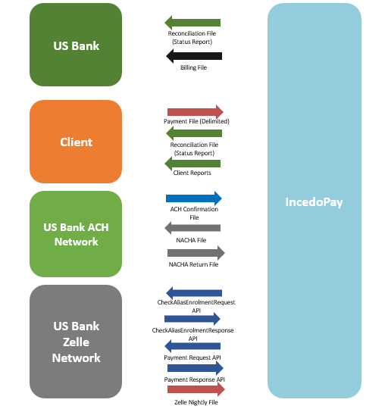
 Delimited Client Files and Zelle Nightly Feed
NACHA Files
APIs Request/Response
ACH Confirmation file (Fixed Width)
Billing file going to US Bank monthly
Reports

Protocols

Input/output – File

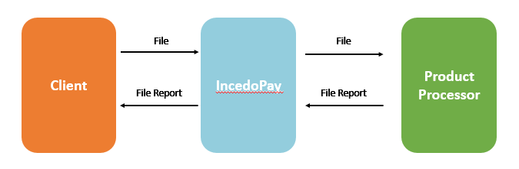

File Transfer Protocol
1 | SFTP

Notes:
- File responses are not restricted to a time period.
- IncedoPay can execute file publishing where a response is not required.
- In case of communication failure between the IncedoPay and a product processor or a clearing system, a configurable set of retries ( 2 retry attempts) can be executed before returning with a negative response to partner system.
- IncedoPay will not perform any retry if there is a negative response provided by the partner system due to exception etc. The retry logic will need to be handled by the partner systems.

Exception Handling

Business Exception
- Validation error - Errors due to mismatch in data type, size, Length etc.
- Lookup Error - If required lookup value is not maintained or available.
- Business Validation & other exceptions from the application layer (e.g., Exceptions like account not found, account blocked ….etc.)
- IncedoPay will show / return generic error messages based on different categories of exceptions raised while executing any operations without returning specific technical exception details

Technical Exception
- Network error - Connectivity errors
- Infrastructure error – Errors due to unavailability of data base.
- File system error - Exception due to file system full etc.
- In technical exceptions, files are sent again (retry) after 30 minutes which is configurable
.

US Bank IncedoPay Connectivity
Inbound/Outbound

Connectivity Details

US Bank
SFTP will be used as communication medium.

Firewall Configuration
Please note: | BEFORE testing begins, the following FIREWALL settings must be in place on YOUR FIREWALL:
Firewall Changes For SSHFTP IP Addresses | 170.135.187.73 => filegateway-test.usbank.com  170.135.187.8 => filegateway.usbank.com  170.135.228.9 => filegateway.usbank.com | Test Server  Production Site Primary Address  Production Site DR Address

This SSHFTP service requires connecting to port 20022

IncedoPay
SFTP will be used as communication medium.

Environment | Naming Convention | Public IP
UAT / QA Environment | VAUQAPP01.incedopay.com | 54.144.15.157
Prod Environment | VAPRDAPP01.incedopay.com | 18.235.202.217
DR Environment | ORDRDAPP01.incedopay.com | 52.32.69.177

Port – 20022

Services

Files & APIs

INPAY-PAYFILE-IN-MS: Payment File

Service Overview
# | Service ID | Description | Use Cases | Origin | Input Format | Destination | Output Format
01 |  | Delimited file receive Payment details | 1.1b, 5.1, 7.1, 8.1, 9.1, 10.1, 13.1 | Client via IncedoPay web upload feature | Delimited | IncedoPay | N/A

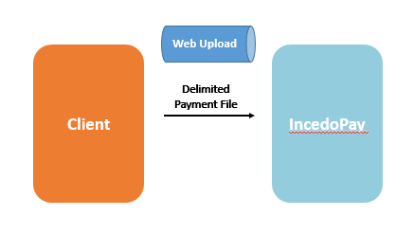
Service Type | INBOUND
Data Exchange Format | Delimited – accepting both “,” and “|” delimiters
Communication protocol | Web Upload
Service Triggering Mode | On Request
Service Operation | External Publish
Estimated Run Frequency | As & when client uploads payment file
Aggregation | Bulk – Multiple records in a single file

File Format Specification
This file follows the Delimited File Format Specification.

File Layout Specification
# | Name | Length | Format | Optional / Required | Remark
1 | Payee ID | 35 | String | Required | Unique Identifier of a consumer
2 | Payee First Name | 35 | String | Required | First Name of consumer
3 | Payee Last Name | 35 | String | Required | Last Name of consumer
4 | Email | 48 | String | Required | To be used as a token and Launch Campaign
5 | Payee Address Line 1 | 30 | String | Conditionally Required | Required if Payment Type is 'Check'
6 | Payee Address Line 2 | 30 | String | Optional
7 | Payee City/Province Name | 30 | String | Conditionally Required | Required if Payment Type is 'Check'
8 | Payee State Code | 2 | String | Conditionally Required | Required if Payment Type is 'Check'
9 | Payee/Postal Code | 10 | String | Conditionally Required | Required if Payment Type is 'Check'
10 | Payee Country Name | 2 | String | Optional | Required value 'US' if Payment Type is 'Check'
11 | Payment Type | 5 | String | Optional | ACH,Zelle,Check(If this field is blank and the consumer does not exist in Incedopay database launch a campaign to get payment preference.
12 | Payment Amount | 10 | Numeric (8.2) | Required
13 | Value Date | 8 | Date | Optional | (Only for ACH)If blank calculate the date based on the time payment is sent to Product processor
14 | Payer Account Number | 17 | String | Required | Required if Payment Type is ACH or blank
15 | Payment Reference | 35 | String | Required | Unique Identifier of a transaction
16 | Phone Number | 20 | String | Conditionally Required | Used for Zell Token & Campaign Launch
17 | Receiver Account Number | 17 | String | Conditionally Required | Required if Payment type is ACH
18 | Receiver Routing Number | 9 | String | Conditionally Required | Required if Payment type is ACH
19 | Memo | 200 | String | Optional
20 | Payment Priority Type | 10 | Number | Optional | If blank, client default timing configured via client portal will apply
21 | Custom field 1 Parameter Name | 64 | String | Optional
22 | Custom field 1 Parameter value | 256 | String | Optional
23 | Custom field 2 Parameter Name | 64 | String | Optional
24 | Custom field 2 Parameter value | 256 | String | Optional
25 | Custom field 3 Parameter Name | 64 | String | Optional
26 | Custom field 3 Parameter Value | 256 | String | Optional
27 | Custom field 4 Parameter Name | 64 | String | Optional
28 | Custom field 4 Parameter value | 254 | String | Optional
29 | Custom field 5 Parameter Name | 64 | String | Optional
30 | Custom field 5 Parameter value | 256 | String | Optional

File Naming Convention
TBD

INPAY-ACHOUT-IN-FL: Payment Response NACHA File

Service Overview
# | Service ID | Description | Use Cases | Origin | Input Format | Destination | Output
02 |  | NACHA file to send payment instructions to ACH Product processor | 1.13a, 8.4 | IncedoPay | NACHA | US Bank NACHA | ACH Confirmation File

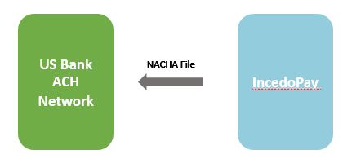
Service Type | outbound
Data Exchange Format | NACHA File
Communication protocol | SFTP
Service Triggering Mode | On Request
Estimated Run Frequency | Configurable(before cutoff window etc)
Aggregation | Bulk – Multiple records per client in a single NACHA file

File Layout Specification

Header Record
Field | Position | Size | Contents | Mandatory/Optional/Required | Description
1 | 01 -01 | 1 | 1 | Mandatory | Record Type Code
2 | 02-03 | 2 | 01 | Mandatory | Priority Code
3 | 04-13 | 10 | B042000013  (B=Blank space) | Mandatory | Immediate Destination
4 | 14 - 23 | 10 |  | Mandatory | Immediate Origin - Nine digit Fed Tax ID with '1' inserted as first character unless notified by U.S. Bank that first character will be different (Incedo Federal Tax ID)
5 | 24-29 | 6 | YYMMDD | Mandatory | File Creation Date
6 | 30-33 | 4 | HHMM | NACHA optional , U.S. Bank Required | File Creation Time
7 | 34-34 | 1 | Alpha/Numeric | Mandatory | File ID Modifier - Using either numbers or letters, indicate sequentially the individual files submitted the same day
8 | 35-37 | 3 | 094 | Mandatory | Record Size
9 | 38-39 | 2 | 10 | Mandatory | Blocking Factor
10 | 40-40 | 1 | 1 | Mandatory | Format Code
11 | 41-63 | 23 | U.S. Bank | Required | Destination Name - left justify, blank fill /
12 | 64-86 | 23 | IncedoPay | Required | Origin Name – The name of the company or third party vendor that is sending the file, left justify, blank fill
13 | 87-94 | 8 | Blanks or 0's |  | Reference Code - Use blank spaces or zeros

SAMPLE

Company/Batch Header Record

Field | Position | Size | Contents | Mandatory/Optional/Required | Description
1 | 01-01 | 1 | 5 | Mandatory | Record Type Code
2 | 02-04 | 3 | 220 | Mandatory | Service Class Code  200 - Mixed Debits and Credits 220 - Credits Only 225 - Debits Only
3 | 05-20 | 16 |  | Mandatory | Company Name – Name of the company by which it is known to & readily recognized by the Receiver of the entry, left justify, blank fill(Client Name)
4 | 21-40 | 20 |  | Optional | Company Discretionary Data - Company Information significant only to your company, left justify, blank fill
5 | 41-50 | 10 |  | Mandatory | Company ID - Nine digit Federal Tax ID with a '1' as first character unless notified by U.S. Bank that first character will be different / (Client Federal Tax ID)
6 | 51-53 | 3 | PPD | Mandatory | **Standard Entry Class Code – Applicable code (see below)
7 | 54-63 | 10 | ‘Refund’ | Mandatory | Company Entry Description - Description of what entries are (payroll,..) left justify, blank fill
8 | 64-69 | 6 | YYMMDD | Optional | Company Descriptive Date
9 | 70-75 | 6 | YYMMDD | Required | Effective Entry Date - Date transactions are to post to the receiving account
10 | 76-78 | 3 | Blanks |  | Settlement Date - Blank spaces, Inserted by ACH Operator
11 | 79-79 | 1 | 1 | Mandatory | Originator Status Code
12 | 80-87 | 8 | 04200001 | Mandatory | Originating DFI Identification - U.S. Bank routing-transit number (1st eight characters)
13 | 88-94 | 7 |  | Mandatory | Batch number - Indicate first batch by '1' sequentially increasing with each batch, right justify, zero fill

SAMPLE

Entry Detail Record

Field | Position | Size | Contents | Mandatory/Optional/Required | Description
1 | 01-01 | 1 | 6 | Mandatory | Record Type Code
2 | 02-03 | 2 |  | Mandatory | **Transaction Code (see below)
3 & 4 | 04-12 | 9 |  | Mandatory | Receiving DFI Identification – The routing number of bank receiving the transaction /  (Consumer Routing Number)
5 | 13-29 | 17 |  | Required | DFI Account Number - Receiving customer/employee account number, left justify, blank fill (Consumer Account Number)
6 | 30-39 | 10 | $$$$$$$$¢¢ | Mandatory | Amount - Dollar Amount of Debit/Credit, right justify, zero fill
7 | 40-54 | 15 |  | FIELD REQUIREMENT IS DEPENDENT UPON SEC CODE, U.S. BANK RECOMMENDED FIELD | Individual ID Number - Company designated unique customer/employee identification /  Consumer ID
8 | 55-76 | 22 |  | FIELD REQUIREMENT IS DEPENDENT UPON SEC CODE, U.S. BANK RECOMMENDED FIELD | Individual name - Customer-Employee name  Consumer Name
9 | 77-78 | 2 |  | Optional | Discretionary Data - Company Discretionary data
10 | 79-79 | 1 | 0 or 1  (0 = Addenda not present  1 = Addenda Present ) | Mandatory | Addenda Record Indicator  0 = Addenda not present 1 = Addenda Present
11 & 12 | 80-87  88-94 | 8  7 | 04200001 | Mandatory | Trace number - right justify, zero fill – The last seven positions is the Entry Detail Sequence Number in ascending order to entries in the batch (0000001, 0000002, 0000003,…)

SAMPLE

Company Batch Control Record

Field | Position | Size | Contents | Mandatory/Optional/Required | Description
1 | 01-01 | 1 | 8 | Mandatory | Record Type Code
2 | 02-04 | 3 |  | Mandatory | Service Class Code 200 - Mixed Debits and Credits 220 - Credits Only 225 - Debits Only
3 | 05-10 | 6 |  | Mandatory | Entry/Addenda Count - Number of entry detail and addenda records (type 6 and 7 records) in batch, right justify, zero fill
4 | 11-20 | 10 |  | Mandatory | Entry Hash - Sum of first eight digits of the routing-transit numbers within the batch, right justify, left truncate
5 | 21-32 | 12 | $$$$$$$$$$¢¢ | Mandatory | Total Debit Entry Dollar Amount - Sum of the debit entry dollar amounts in batch, right justify, zero fill
6 | 33-44 | 12 | $$$$$$$$$$¢¢ | Mandatory | Total Credit Entry Dollar Amount - Sum of the credit entry dollar amounts in batch, right justify, zero fill
7 | 45-54 | 10 |  | Required | Company ID - Nine digit Federal Tax ID with a '1' as first character unless notified by U.S. Bank that first character will be different
8 | 55-73 | 19 |  | Optional | **Message Authentication Code (MAC) – An eight character code derived from a special key used in conjunction with the DES algorithm. Remaining eleven positions of this field to remain blank.
9 | 74-79 | 6 | Leave Blank |  | RESERVED – Do not fill in
10 | 80-87 | 8 | 04200001 | Mandatory | Originating DFI Identification - U.S. Bank routing-transit number
11 | 88-94 | 7 |  | Mandatory | Batch Number - Indicate first batch by '1' sequentially increasing with each batch, right justify, zero fill

SAMPLE
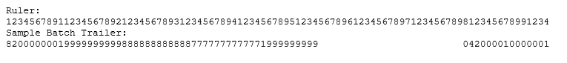

File Control Record

Field | Position | Size | Contents | Mandatory/Optional/Required | Description
1 | 01-01 | 1 | 9 | Mandatory | Record Type Code
2 | 02-07 | 6 |  | Mandatory | Batch Count - Number of batches (Type 8 records) in the file, right justify, zero fill
3 | 08-13 | 6 |  | Mandatory | Block Count - Sum of all records divided by 10 and rounded to the next highest integer, right justify, zero fill
4 | 14-21 | 8 |  | Mandatory | Entry Addenda Count - Number of entry detail and addenda records (Type 6 and 7 records) in file, right justify, zero fill
5 | 22-31 | 10 |  | Mandatory | Entry Hash - Sum of first eight digits of the routing-transit numbers within file, right justify, left truncate
6 | 32-43 | 12 | $$$$$$$$$$¢¢ | Mandatory | Total Debit Entry Dollar Amount - Sum of the debit entry dollar mounts in file, right justify, zero fill
7 | 44-55 | 12 | $$$$$$$$$$¢¢ | Mandatory | Total Credit Entry Dollar Amount - Sum of the credit entry dollar mounts in file, right justify, zero fill
8 | 56-94 | 39 | Blanks |  | Reserved - Do not fill in

SAMPLE
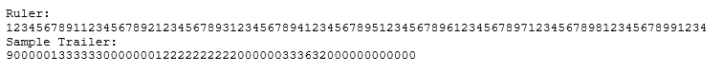

File Naming Convention
TBD
Note : Refer to section 6.10 for Common Entry Class codes and refer to Section 6.11 for Common Transaction Codes.

INPAY-ACHCONF-: ACH Confirmation File

Service Overview
# | Service ID | Description | Use Cases | Origin | Input Format | Destination | Output
03 |  | Using a delimited file receive ACH confirmation file | 1.23, 8.6a | US Bank | Fixed Width File | IncedoPay | N/A

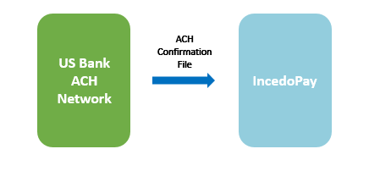
Service Type | INBOUND
Data Exchange Format | Fixed Width File
Communication protocol | SFTP
Service Triggering Mode | As soon as NACHA file sent to US Bank Product Processor
Estimated Run Frequency | N/A
Aggregation | Bulk – Multiple records in a single file

File Format Specification
This file follows the Fixed Width File Format Specification.
File Layout Specification
Field | Position | Size | Contents | Description
1 | 01-09 | 9 | INCEDORF | Customer Point Name
2 | 10-11 | 2 |  | Filler
3 | 12-41 | 30 | INCEDO REFUND MANAGEMENT | Customer Name Description
4 | 42-43 | 2 |  | Filler
5 | 44-67 | 24 | INCEDO.A01 | Pre-Processor Dataset name (varied lengths up to 24 characters)
6 | 68-69 | 2 |  | Filler
7 | 70 | 1 | T (Standard Formatted Transmission) | Delivery Method of File Confirmation
8 | 71-72 | 2 |  | Filler
9 | 73-73 | 1 | Blank | File Total Requirements
10 | 74-75 | 2 |  | Filler
11 | 76-81 | 6 | 030618 | File Confirmation Date = YYMMDD
12 | 82-82 | 1 |  | Filler
13 | 83-88 | 6 | 084951 | File Confirmation Time = HHMMSS
14 | 89-97 | 9 | ‘ CREATE ‘ | Literal ‘ CREATE ‘
15 | 98-103 | 6 | 030618 | File Creation Date = YYMMDD
16 | 104-104 | 1 |  | Filler
17 | 105-110 | 6 | 184150 | File Creation Time = HHMMSS
18 | 111-112 | 2 |  | Filler
19 | 113-113 | 1 | A | File ID Modifier from Input File
20 | 114-115 | 2 |  | Filler
21 | 116-121 | 6 | 000006 | Batch Count from Input File
22 | 122-125 | 4 | ‘ IT ‘ | Literal ‘ IT ‘
23 | 126-133 | 8 | 00005678 | Batch Item Count from Input File
24 | 134-137 | 4 | ‘ DR ‘ | Literal ‘ DR ‘
25 | 138-149 | 12 | 000000123456 | Debit Amount from Input File without the decimal  Displayed. Value is 1234.56
26 | 150-153 | 4 | ‘ CR ‘ | Literal ‘ CR ‘
27 | 154-165 | 12 | 000000987654 | Credit Amount from Input File without the decimal  Displayed. Value is 9876.54
28 | 166-166 | 1 |  | Filler
29 | 167-169 | 3 | Nnn | Fatal Error Message Number (see page 3 for list of error codes )
30 | 170-171 | 2 |  | Filler
31 | 172-172 | 1 | N = None, no error  Y = Yes, error(s) encountered | More Fatal Errors Indicator
32 | 173-174 | 2 |  | Filler
33 | 175-244 | 70 | ACH SERVICES RECEIVED YOUR FILE FOR PROCESSING  or  ACH SERVICES RECEIVED YOUR ACH FILE AND TOTALS FOR PROCESSING  or  ERR: EFFECTIVE ENTRY DATE IS NOT A VALID BUSINESS DATE. | Message 1:  If the file is good, this is the confirmation message.  *file confirmation setup for transmission method only  If the file is good, this is the confirmation message.  *file confirmation setup for IVR (phone call) and transmission methods  If the file is fatal, this is the error message
34 | 245-246 | 2 |  | Filler
35 | 247-316 | 70 | PLEASE CONTACT ACH SERVICES AT 800-944-7504 | Message 2:  Only for fatal files, blank for good files
36 | 317-318 | 2 |  | Filler
37 | 319-327 | 9 | Nnnnnnnnn | Billing Account Transit Routing Number
38 | 328-329 | 2 |  | Filler
39 | 330-346 | 17 | Nnnnnnnnnnnnnnnnn | Billing Account Number
40 | 347-348 | 2 |  | Filler
41 | 349-395 | 47 |  | RESERVED
42 | 396-405 | 10 |  | Hash Total
43 | 406-500 | 95 |  | Filler (future expansion)

Refer to section 6.10 for ACH confirmation file error codes and description.

File Naming Convention
TBD

INPAY-NACHARETURN-: NACHA RETURN File

Service Overview
# | Service ID | Description | Use Cases | Origin | Input Format | Destination | Output
04 |  | NACHA Return file to receive total ACH transactions statuses | 8.8 | US Bank ACH network | NACHA | IncedoPay | N/A

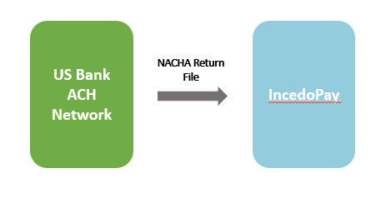
Service Type | INBOUND
Data Exchange Format | NACHA
Communication protocol | SFTP
Service Triggering Mode | As & when file is available
Estimated Run Frequency | N/A
Aggregation | Bulk – Multiple records in a single file

File Format Specification
This file follows the NACHA file Format Specification.
File Layout Specification
Refer to section 6.15 for NACHA return file layout specifications.

INPAY-CHKAlias_: CheckAliasEnrollmentRequest API

Service Overview
# | Service ID | Description | Transport Method | Use Cases | Origin | Input Format | Destination | Output
05 |  | This operation will allow user to check the enrollment status of a given alias. When a request is made, the backing system will return the enrollment status of the given alias, if the request call goes through successfully. Otherwise a call failure status will be returned. | API | 5.12 | IncedoPay | N/A | US Bank Zelle Network | Return Enrolment Status

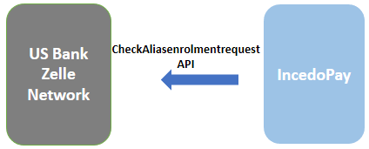
Service Type | outbound
Communication protocol | SOAP
Service Triggering Mode | On Request
Estimated Run Frequency | On Request
Aggregation | Single

Token Request Specification
Name | Type | Width | Req? | Description
CheckAliasEnrollmentRequest |  |  | Y
PayerID | String | 3..10 | Y | The payer ID of the payer for which this operation is accessible.
Alias | String | 1..48 | Y | The email address or phone number to which the payment was directed.  A.k.a. "Token".

First email token of a consumer will be sent if the response is “Token Not Active”
Next API call with phone number will be made i.e. For a single consumer two token request can be made.

IP-CONSALIENRLRES-IN-FL:: CheckAliasEnrollmentResponse API

Service Overview
# | Service ID | Description | Use Cases | Origin | Input Format | Destination | Output
06 |  | API to receive consumer enrolment status | 5.12 | IncedoPay | N/A | US Bank Zelle Network | Return Enrolment Status
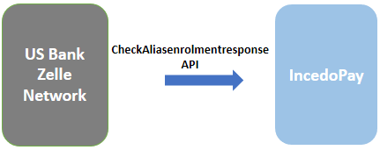
Service Type | INBOUND
Data Exchange Format | N/A
Communication protocol | SOAP
Service Triggering Mode | On Request
Estimated Run Frequency | N/A
Aggregation | Individual/Single

Response Layout Specification
Name | Type | Width | Req? | Description
CheckAliasEnrollmentReply |  |  | Y
Status |  |  | Y
StatusCode | Integer |  | Y | This list provides the complete set of valid Response Status codes defined for the response Status Aggregate Status Code along with conditions that may cause the Response Status to be sent.
Severity | String | 0..80 | Y | The severity is assigned once a Status Code is selected for the specific source systems code. values: Warning, Info, Error
StatusDescription | String | 0..255 | Y | Status text is provided in the Status Desc field
ServerStatusCode | String | 0..20 | N | This status code will be the source system's status code
ServerStatusDescription | String | 0..255 | N | This status description will be the source system's status description
AdditionalStatus |  |  | N
StatusCode | Integer |  | Y | This list provides the complete set of valid Response Status codes defined for the response Status Aggregate Status Code along with conditions that may cause the Response Status to be sent.
Severity | String | 0..80 | Y | The severity is assigned once a Status Code is selected for the specific source systems code. values: Warning, Info, Error
StatusDescription | String | 0..255 | Y | Status text is provided in the Status Desc field
ServerStatusCode | String | 0..20 | N | This status code will be the source system's status code
ServerStatusDescription | String | 0..255 | N | This status description will be the source system's status description
Alias | String | 1..48 | Y | The email address or phone number to which the payment was directed.  A.k.a. "Token".
AliasEnrollmentStatus | String | 1...18 | Y | One of values {ALIAS_ENROLLED, ALIAS_NOT_ENROLLED, CHECK_CALL_FAILED}

See section 6.9 'Unified Status Response Codes List' for possible status response codes.

INPAY_PAYAPI_: MakePaymentRequest API

Service Overview
# | Service ID | Description | Transport Method | Use Cases | Origin | Input Format | Destination | Output Format
07 |  | This API will be used to make payment request to Zelle Network. If the payment is Sucessful, a payment Id will be returned in the reply otherwise error message(s) will be returned. |  |  | IncedoPay |  | US Bank Zelle Network

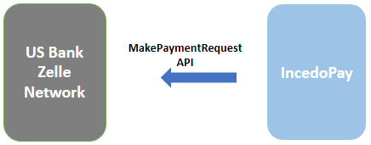
Service Type | OuTBOUND
Data Exchange Format | API
Communication protocol | SOAP
Service Triggering Mode | On Request
Estimated Run Frequency | N/A
Aggregation | Single

Token Request Specification
Name | Type | Width | Req? | Description
MakePaymentRequest |  |  | Y
PayerID | String | 3..10 | Y | The payer ID of the payer creating the payment.
DoublePostingToken | String | 1..20 | Y | A random unique token used for identifying a request as being unique. This avoids double posting of the same payment.  The DoublePostingToken value (for this and all similar services) is required to be globally unique for the payer. Submitting an already-used value will cause the call to return in error.
RecipientDetail |  |  | Y
Alias | String | 1..48 | Y | Email or Phone Number to which the Payment will be submitted
AliasType | String |  | Y | The type of the alias. One of the following values:  EMAIL, MOBILE
FirstName | String | 1..50 | Y | Recipient first name (As received in Incoming File)
LastName | String | 1..50 | Y | Recipient last name.
RecipientAddress |  |  | N | Recipient Address for check processing
StreetAddress1 | string | 1..100 | N | Street address
StreetAddress2 | string | 1..100 | N | Street address line 2
City | string | 1..30 | N | City
State | string | 2 | N | State. Must be a valid US two-letter state code.
Zipcode | string | 1..16 | N | Zip code.  Must be in format of ##### or #####-####
Country | string | 2 | N | Recipient Country.  Allows values: US
PaymentDetail |  |  | Y | Payment Details
PayFromAccountNumber | string | 1..23 | N | Payment account from which funds are taken for this payment.  If not specified, the default payment account for the payer will be used.  If not specified, and no default payment account exists for the Payer, the payment will fail.—This is not mandatory
Amount | decimal | 0..9,2 | Y | Payment amount.
PriorityType | string |  | Y | Specifies type of Zelle payment. Allowed values:  STANDARD - Specifies a Zelle standard payment should be created.  INSTANT - Requests a Zelle instant payment. Instant payments will be downgraded to standard payments if the receiving financial institution does not support them.
Memo | string | 1..200 | N | Information/message to the recipient to be included in the payment notification.
ExpirationDays | string | 2 | N | Number of calendar days the payment is available to the recipient before being cancelled.  If not specified, uses default defined for Payer.  Client Specific Expiration date ( Include in payment file)  If the payment expiration day is 0
PaymentParameters |  |  | N | Payment parameters are arbitrary name/value pairs attached to the payment. Up to 5 pairs are allowed
PaymentParameter |  |  | N | A single name/value pair
Name | string | 1..64 | Y | Parameter Name
Value | string | 1..256 | Y | Parameter Value
UpdateUser | string | 1..16 | Y | User ID of the user creating/updating this record.  This user identifier will be stored in the backing database in the 'create_user' or 'last_update_user' as appropriate.

INPAY-PAYRESP: MakePaymentResponseAPI

Service Overview
# | Service ID | Description | Use Cases | Origin | Input Format | Destination | Output Format
08 |  | API to receive Zelle specific payment responses |  | US Bank Zelle Network |  | IncedoPay
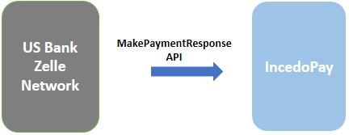
Service Type | INBOUND
Data Exchange Format | API
Communication protocol | SOAP
Service Triggering Mode | On Request
Estimated Run Frequency | N/A
Aggregation | Single

Response Layout Specification
Name | Type | Width | Req? | Description
RetrievePayerReply |  |  | Y
Status |  |  | Y
StatusCode | integer |  | Y | This list provides the complete set of valid Response Status codes defined for the response Status Aggregate Status Code along with conditions that may cause the Response Status to be sent.
Severity | String | 0..80 | Y | The severity is assigned once a Status Code is selected for the specific source systems code. values: Warning, Info, Error
StatusDescription | String | 0..255 | Y | Status text is provided in the Status Desc field
ServerStatusCode | String | 0..20 | N | This status code will be the source system's status code
ServerStatusDescription | String | 0..255 | N | This status description will be the source system's status description
AdditionalStatus |  |  | N
StatusCode | integer |  | Y | This list provides the complete set of valid Response Status codes defined for the response Status Aggregate Status Code along with conditions that may cause the Response Status to be sent.
Severity | String | 0..80 | Y | The severity is assigned once a Status Code is selected for the specific source systems code. values: Warning, Info, Error
StatusDescription | String | 0..255 | Y | Status text is provided in the Status Desc field
ServerStatusCode | String | 0..20 | N | This status code will be the source system's status code
ServerStatusDescription | String | 0..20 | N | This status description will be the source system's status description
PaymentInstructionID | String | 15 | Y | The primary key of the retrieved payment instruction record.
ZellePaymentID | String | 12 | N | The Zelle payment identifier for a payment that was sent to the Zelle system.  Available if the payment was successfully submitted for processing.
PaymentStatus | String | 1..20 | N | Overall status of the payment. One of the following values:  { LOADED, PROCESSING, PENDING_ENROLLMENT, PROCESSING_FAILED, EXPIRED, CANCELED, PENDING, PENDING_PROCESSING, FAILED, SENT, PENDING_ACCEPTANCE, ACCEPTED, DELIVERED, CHECK_PROCESSING, CHECK_UNDELIVERABLE, CHECK_ISSUED }  A.k.a. "Customer Status"

See section 6.9 'Unified Status Response Codes List' for possible status response codes.

INPAY-CNCLPMT: CancelPaymentRequest API

Service Overview
# | Service ID | Description | Transport Method | Use Cases | Origin | Input Format | Destination | Output Format
09 |  | This operation allows user to cancel an existing payment. If the cancellation goes through a success status will be returned in the reply otherwise error message(s) will be returned.  The cancellation can be made either via the PaymentID field which can be either ZellePaymentID or the PaymentInstructionID. If PaymentID is not supplied, an error is thrown. |  |  | IncedoPay |  | US Bank Zelle Network

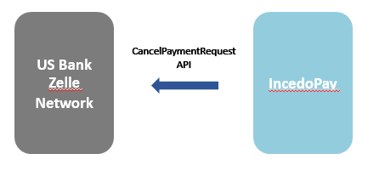
Service Type | OuTBOUND
Data Exchange Format | API
Communication protocol | SOAP
Service Triggering Mode | On Request
Estimated Run Frequency | N/A
Aggregation | Single

Token Request Specification
Name | Type | Width | Req? | Description
CancelPaymentRequest |  |  | Y
PayerID | string | 3..10 | Y | The payer ID of the payer for which this payment was created.
PaymentID | string | 12..15 | Y | It can be either the Zelle payment identifier or B2C internal payment instruction ID.
Alias | string | 1..48 | N | The email address or phone number to which the payment was directed. A.k.a. "Token".
Amount | decimal | 1..12,2 | N | The dollar amount of the payment. Specified when payment was created.
UpdateUser | string | 1..16 | Y | User ID of the user creating/updating this record.  This user identifier will be stored in the backing database in the 'create_user' or 'last_update_user' as appropriate.

INPAY-ANCPAYRESP: CancelPaymentResponseAPI

Service Overview
# | Service ID | Description | Use Cases | Origin | Input Format | Destination | Output Format
09 |  | API to receive Zelle specific payment cancellation responses |  | US Bank Zelle Network |  | IncedoPay
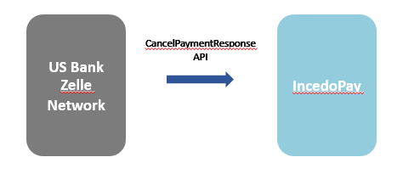
Service Type | INBOUND
Data Exchange Format | API
Communication protocol | SOAP
Service Triggering Mode | On Request
Estimated Run Frequency | N/A
Aggregation | Single – Single records in a single call

Response Layout Specification
Name | Type | Width | Req? | Description
CancelPaymentReply |  |  | Y
Status |  |  | Y
StatusCode | integer |  | Y | This list provides the complete set of valid Response Status codes defined for the response Status Aggregate Status Code along with conditions that may cause the Response Status to be sent.
Severity | String | 0..80 | Y | The severity is assigned once a Status Code is selected for the specific source systems code. values: Warning, Info, Error
StatusDescription | String | 0..255 | Y | Status text is provided in the Status Desc field
ServerStatusCode | String | 0..20 | N | This status code will be the source system's status code
ServerStatusDescription | String | 0..255 | N | This status description will be the source system's status description
AdditionalStatus |  |  | N
StatusCode | integer |  | Y | This list provides the complete set of valid Response Status codes defined for the response Status Aggregate Status Code along with conditions that may cause the Response Status to be sent.
Severity | String | 0..80 | Y | The severity is assigned once a Status Code is selected for the specific source systems code. values: Warning, Info, Error
StatusDescription | String | 0..255 | Y | Status text is provided in the Status Desc field
ServerStatusCode | String | 0..20 | N | This status code will be the source system's status code
ServerStatusDescription | String | 0..255 | N | This status description will be the source system's status description

See section 6.9 'Unified Status Response Codes List' for possible status response codes.

Billing File

Service Overview
# | Service ID | Description | Use Cases | Origin | Input Format | Destination | Output
10 |  | Monthly Billing File | N/A | IncedoPay | Delimited | US Bank Billing | N/A

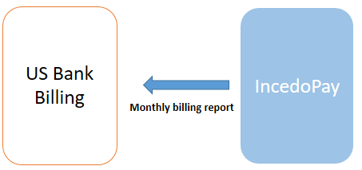
Service Type | OutBound
Data Exchange Format | Delimited File
Communication protocol | email to zelle.b2c.operations@usbank.com
Service Triggering Mode | Month End report
Estimated Run Frequency | Once a month; 2nd business day (e.g., activity for 10/1/18 through 10/31/18 should be emailed on Nov 2)
Aggregation | Bulk Multiple records in a single file

Billing File layout Specifications

Filed | Value
TranCode | 80 (Always 80)
BankNumber | Bank # to be provided by US Bank
productCode | DDA (Always DDA)
accountNumber | Client Account Number ( Provided at on-boarding)
Date | YYYMMDD (first digit is the century, which is 1) Use the analysis month, not the current month the file is sent. E.g., for October activity that is emailed on the 2nd business day of November, the date would be 1181001).
elementId | Codes of activities(See Table Below)
tranType | N (Always N)
Method | I (Always I)
Count | (The count of this type of transaction for this payer)
Provider Source | NCDO
Operator Id | Jvmastb (configurable)

Element ID
Element ID | Description | Type | Methodology
DDA30106 | Set up | One time | per new client set up/added to the portal in the billing period
DDA30100 | Monthly Maintenance | Monthly | per client live on the portal in the billing period e.g. volume = 1 per client, per month
DDA30101 | Campaign | Transactional | per campaign email/text initiated
DDA30104 | Enrollment | Transactional | per successful consumer enrollment
DDA30102 | Emails | Transactional | per email sent to consumers, excluding initial campaign email
DDA30103 | Text | Transactional | per text sent to consumers, excluding initial campaign text
DDA30105 | Transactions | Transactional | per payment

NOTE : Monthly Billing file will be sent by Incedopay at zelle.b2c.operations@usbank.com .

INPAY-ENRL-RPT: Daily Enrolment Report

Service Overview
# | Service ID | Description | Use Cases | Origin | Input Format | Destination | Output Format
12 |  | This report will be available for download and will be sent to client on email & text at the end of day. It will contain details of the consumers that have enrolled in the system on a daily basis. |  | IncedoPay | N/A | Client | Delimited

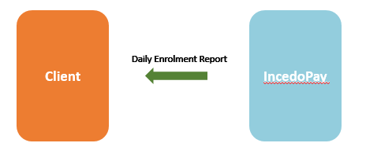
Service Type | REPORT Download
External Service | NO
Data Exchange Format | Delimited – using the delimiter configured for reports in the client profile
Communication protocol | SFTP + UI Download
Service Triggering Mode | On Request from UI
Service Operation
Estimated Run Frequency | Daily, End of Day
Aggregation | All enrolments for a given day

File Layout Specification
# | Name | Definition
1 | Payee ID | Payee Identification
2 | Payee First Name | Payee First Name
3 | Payee Last Name | Payee Last Name
4 | Email Address | Email of the enrolled Payee
5 | Phone Number | Phone Number of the Payee
6 | Payment Preference | Payment preference input by Payee (ACH,Zelle,Check)
7 | Date of Change
8 | Action Type | New/Update
9 | Client Id
10 | Client Name
11 | Address Line 1
12 | Address Line 2
13 | City
14 | State
15 | Postal Code

File Naming Convention
TBD : – File naming conventions provided to Priyanka and Ronny on 10/19 (per Mike Connolly)

INPAY-REJECTEMAIL-RPT: Reject Email/Text Report

Service Overview
# | Service ID | Description | Use Cases | Origin | Input Format | Destination | Output Format
13 |  | This report will be generated at the end of the day and will provide the details of the consumer whose emails/Text failed and available for download.  This report will also be sent on email & Text to client |  | IncedoPay | N/A | Client | Delimited

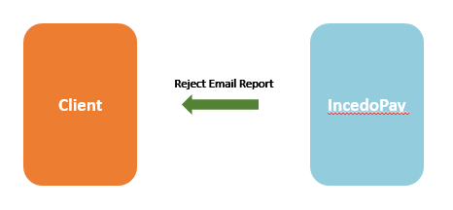
Service Type | REPORT Download
External Service | NO
Data Exchange Format | Delimited – using the delimiter configured for reports in the client profile
Communication protocol | SFTP + UI Download
Service Triggering Mode | On Request from UI
Service Operation
Estimated Run Frequency | Daily, End of Day
Aggregation | All rejections for a given day.

File Layout Specification
# | Name | Definition
1 | Payee ID | Consumer Identifier
2 | Payee First Name | Consumer First Name
3 | Payee Last Name | Consumer Last Name
4 | Payee Email/Text Address | Email or Phone number of the enrolled consumer
5 | Date of Email/Text Rejection
6 | Reasons of Rejection

File Naming Convention
File Follows the General File Naming Convention
TBD
Example Name:

INPAY-PAYREP Reconciliation Files Report

Service Overview
# | Service ID | Description | Use Cases | Origin | Input Format | Destination | Output Format
11 |  | Using a delimited file send payment status updates to Client & US Bank at the end of the day. |  | IncedoPay | N/A | Client & US Bank | Delimited

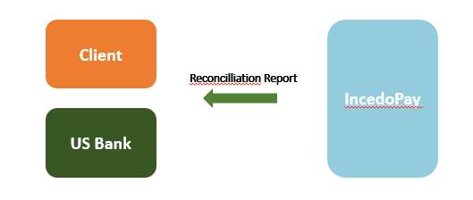
Service Type | Outbound
External Service | NO
Data Exchange Format | Delimited – using the delimiter configured for reports in the client profile
Communication protocol | SFTP + UI Download
Service Triggering Mode | On Request
Estimated Run Frequency | Daily, End of Day
Aggregation | Bulk, Client Specific

File Layout Specification
# | Name | Length | Format | Optional / Required | Remark
1 | Client ID | 35 | String | Required | ID
2 | Timestamp |  | Date/time | Required | Date/time when this update was generated, in the following format: YYYYMMDDHHMMSSmmm
3 | Payment Reference | 35 | Number | Required | Unique ID of transaction
4 | Payee ID | 35 | String | Required
5 | Payment Type | 4 | String | Required | ACH or Zelle or Check
6 | Acceptance Date | 10 | MM/DD/YYYY | Required
7 | Clearing Reference |  | String | Optional | ACH Trace Number, for ACH payments.  Zelle Payment Id, for Zelle payments (which corresponds to the right 7 digits of the ACH Trace Number).
8 | Clearing File Name |  | String | Optional | Name of the file sent to Clearing.
9 | Payment Status | 50 | String | Required | Current Status of the payment
10 | Return or Correction Reason Code | 35 | String | Conditionally Required | possible return or correction reasons codes.
11 | Return or Correction Reason Code Description | 255 | String | Conditionally Required | possible return or correction reasons codes description.

File Naming Convention
TBD

Frequency of Status Report
The frequency of this file is ONCE a day, per client:
- The time of delivery of the report is dependent on the client configuration

Zelle Nightly File

Service Overview
# | Service ID | Description | Use Cases | Origin | Input Format | Destination | Output
13 |  | Receive Zelle payment status updates | N/A | US Bank Zelle Network | N/A | IncedoPay | N/A

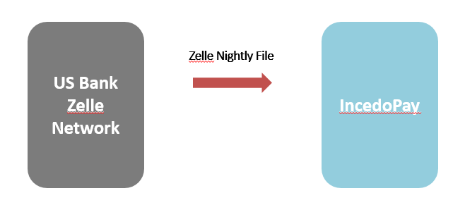
Service Type | INbound
Data Exchange Format | Delimited
Communication protocol | SFTP
Service Triggering Mode | On Request
Estimated Run Frequency | Daily, End of Day
Aggregation | Bulk, Client Specific

File Layout Specification
Header: | Req. | Size
Record Type | Y | “Header” |  | Indicates this record contains header information
PayerID | Y | 3-10 | Alpha and/or numeric
File Date | Y | 8 | Date | Date file should be create
Update Records:
Record Type | Y | “Payment” |  | Indicates this record contains information on payment record
Payment Instruction ID | Y | 15 | Alpha/Numeric | Identifier assigned to payment instructions when received into B2C application. All instructions that passed initial parsing will have an origination identifier
Zelle Payment ID | N | 12 | Alpha/Numeric | Zelle payment ID is the identifier assigned a payment by Early Warning Systems (EWS, previously clear exchange). Every payment that has been sent to EWS will have this identifier
Payment Creation Date | Y | 8 | Date | Date transaction was received into B2C
Token | Y | 48 if Email  10-14 if Mobile | Alpha and/or numeric and special characters if Email  Numeric if Phone  Numeric, Spaces, Paren and dash "1-(234) 5678901" | Token payment was sent to
Amount | Y | 12 + 2 | 12 numeric before decimal and 2 numeric after | Amount sent to the recipient
Customer Payment Status | Y | 20 | Alpha and/or numeric and special characters | If the payment instruction has been sent to Hogan it will have one of the following status’.  - Pending  - Pending-acceptance  - Sent  - Delivered  - Failed  - Expired  If the payment instruction has not been sent to Hogan it will have one of the following status’  - Pending Enrollment  - Expired  If the payment has expired and a check is being sent it will have one of the following status’  - Check processing  - Check undeliverable  - Check issued
Failure Description | N | 35 | If payment status is “Failed” this field will contain a value | If payment fails the reason is listed here, including ODS code and rejection reason.
Check Number | N | 1-10 | Numeric | Number of the check if issued for an expired payment
Parameter Name 1 | N | 0-64 | Alpha and/or numeric and special characters
Parameter Value 1 | N | 0-256 | Alpha and/or numeric and special characters | Required if Parameter Name is present
Parameter Name 2 | N | 0-64 | Alpha and/or numeric and special characters
Parameter Value 2 | N | 0-256 | Alpha and/or numeric and special characters | Required if Parameter Name is present
Parameter Name 3 | N | 0-64 | Alpha and/or numeric and special characters
Parameter Value 3 | N | 0-256 | Alpha and/or numeric and special characters | Required if Parameter Name is present
Parameter Name 4 | N | 0-64 | Alpha and/or numeric and special characters
Parameter Value 4 | N | 0-256 | Alpha and/or numeric and special characters | Required if Parameter Name is present
Parameter Name 5 | N | 0-64 | Alpha and/or numeric and special characters
Parameter Value 5 | N | 0-256 | Alpha and/or numeric and special characters | Required if Parameter Name is present
Transaction Summary:
Record Type | Y |  | “Trailer” | Indicates this record contains trailer information
Total Payment Records | Y |  | Numeric | Number of payment records contained in file

File Naming Convention
TBD

Functional Requirements
The following list of features and use cases list all the requirements that are implemented and flows are supported.

FR-1 Client File Submission
Clients will be able to submit payment data files in CSV format.
- Payment File containing payee records along with their payment details will be uploaded into IncedoPay via web upload feature of IncedoPay client portal.
- Once file uploaded by client, Files will be processed immediately. File structure will be validated by IncedoPay and real time file status will be displayed to client.
- File will include Consumer contact details and identifying information, to trigger an enrolment campaign if payee doesn’t exist in IncedoPay Database.
- CSV files can be comma or pipe delimited. Both delimiters should not be used in the same file. The delimiter that the client will use will be defined during Client onboarding, and stored in the Client configuration.

Exception Handling:
- In case complete file fails due to incorrect delimiter/ file structure, error message will be displayed to client in client portal & client will re-submit the correct file. Refer to section 6.8 for file level errors.
- In case of any record level exception, correct records will be successfully processed and file status will be ‘file processed with exception’. Then, client will be able to correct and re-submit erroneous records as error records will be displayed in editable grid format on the portal.
Refer to Section 4.1 for the workflow reference.

FR-2 Processing of Payment File
The system is able to accept payment file submitted by client.
- Client will be able to upload the file into the IncedoPay Client Portal.
- New payments will have duplicate detection applied, in order to prevent the client from submitting duplicate payments.
- The fields that need to be unique are: payment reference, Payee Id & Payment amount.(Combination is to be unique)
Incoming file Blank Payment Type
- For Payment File with Blank value in payment type field payments exceeding client configurable threshold amount require client approval in payment exchange portal prior to processing the payment. On successful approval, normal processing will continue. For erroneous payments, the client will be able to reject the payment in payment exchange portal and in such cases, the payments will be rejected in IncedoPay.
- This will be determined by a X-character code or no value that describes the payment method to use, as indicated in the incoming file format. For blank payment types, no data will be received in this field.
- For Blank payment type where consumer preferences are used, the payment message will be enriched with the settlement details from the beneficiary database.
- If the Consumer is not found in the beneficiary database, the payment will be held until the Consumer is enrolled. Depending on the number of days configured in IncedoPay for expiry of enrolment campaigns, the payment will be cancelled/Rejected.
- If the consumer is found in the beneficiary database but the consumer is dormant, the payment will be held until the consumer is reactivated in payment exchange. Depending on the number of days configured for payment deactivation, the default payment method defined by the Client will be used.

Incoming File with Payment type ( ACH,Check,Zelle)

- For a record, which already include payment type and details, will be transformed and dispatched to the appropriate processor, with no checks on the beneficiary database required.
- This will be determined by a 3-character code that describes the payment method to use. Payments in scope in the current phase, this code can currently contain the values ACH, CHK and ZEL.
- All N records already including payment types exceeding client configurable threshold amount require client approval in payment exchange portal prior to processing the payment. On successful approval, normal processing will continue. For erroneous payments, the client will be able to reject the payment in payment exchange portal and in such cases, the payments will be rejected in IncedoPay.
- The settlement details will only be obtained from the input file. Any Consumer preference in the database will be ignored, as the beneficiary database is not consulted at all.
- If any payment details are missing in the input payment file (such as the account or routing number in case of an ACH payment, or the address in case of a check payment), the payment will be rejected. These details will not be retrieved from the beneficiary database
Note: If US Bank wants to use any other parameter for detecting duplicate payment,please inform.

FR-3 Validation for the Processing of Payment File
- For beneficiary of each payment, the system will check that their accounts are active.
- Every certain time when payee doesn’t exist in IncedoPay, IncedoPay will request payees to confirm the payment method and details.(Campaign Launch) if a response is not received in a certain (configurable) number of days, the payment will be marked as ‘Expired’ and clients will have to re-upload the payment.
- The campaign email will be sent with from email address Clientname@incedoPay.com
- This functionality is configurable per Client, who may decide not to use it altogether. This could be set with a flag or setting the number of days to a very high number.
- This check is at the transaction level. As such, only the current transaction is affected by this check; the remaining transactions will be processed normally.
- The Consumer profile should maintain whether the profile is active or not.
- If the consumer profile is dormant, then consumer profile verification will be attempted. If there is no verification response after a configurable number of days, the payment will be rejected.
Payment Type | Payee in IncedoPay Database | Is Payee Profile Valid | Expected Action | Expected payment method | Expected payment details
Blank | No | N/A | Enrolment campaign launched for Payee | Payment method selected by payee during enrolment | From IncedoPay Consumer Database
Blank | Yes | No | Profile Validation will be required | Payment method chosen by payee post profile validation | From IncedoPay Consumer Data Base
Blank | Yes | Yes | Payment will be processed as per chosen payment preference | from consumer DB | From IncedoPay Consumer Data Base
ACH | No | N/A | Payment will be processed as per ACH payment processing | From Input File | From Input File
ACH | Yes | No |  | From Input File | From Input File
ACH | Yes | Yes |  | From Input file | From Input file
CHK | No | No | Payment will be processed as per CHK payment processing | From Input File | From Input File
Zelle | No | No | Payment will be processed as per Zelle payment processing | From Input File | From Input File

Refer to Section 4.4 and Section 4.5 for the workflow reference.

FR - 4 Client Configurations
- Client should be able to update their preferences via the IncedoPay Client portal.
Refer to section 6.7 for client configurations.

Payment Transformation & Delivery to US Bank product processors

FR-5 ACH Payment Processing
- ACH payment will be transformed into NACHA format. File will be in accordance with the NACHA specifications and any validations will have been performed before the file is submitted to US Bank ACH product processor.
- Every time IncedoPay send NACHA file to US Bank ACH product processor, IncedoPay will receive ACH Confirmation file.
- As & when available, IncedoPay will receive NACHA return file basis on which IncedoPay will match the totals.
- NACHA Files sent by IncedoPay must be in accordance with the NACHA specifications. Any validations will have been performed before the file is submitted to US Bank ACH Network.
- The payment reference Id / EndToEndId field should be propagated to the NACHA file.
- Transmission will happen over Secured File Transfer Protocol.
- Payments that are ready to be processed will be sent immediately to US Bank ACH Network in file format. Files can be sent at a minimum 5 minutes apart.
- Other payments will be sent once their respective Consumer validations or enrolments are complete. These payments will be batched in several files per day, IncedoPay will be passing files to US Bank ACH Network can occur upto 5 times a day initiating from 9:00 am to 10:30 pm CT for current day processing wherein timings will be configurable. No files should be sent from midnight on Friday to Sunday at noon.
- Available payments from all clients are distributed in separate NACHA files per client. Files can be sent at a minimum 5 minutes apart.
- File will be created after every 2 hours of time interval wherein time will be configurable. There are no file size limitations.
- All Production Support issues with files or transactions in files will be handled by the IncedoPay Ops team.
- There will be no IAT transactions in scope.
- Returns files received from US Bank ACH Network will be processed to update the status of transactions in the system. U.S. Bank will not create/send a return file if no activity/data.

Refer to section 4.7 for workflow reference.

FR-6 Zelle Payment Processing
- For consumer driven payment methods Zelle payments, Incedopay will send a token to US Bank Zelle network to verify payee enrolment with Zelle while launching campaign. Token will be sent via “CheckAliasEnrollmentRequest” API to Zelle network.
- IncedoPay will invoke the “CheckAliasEnrollmentReply” API to find out whether payees are enrolled with Zelle.

- All tokens and data will be managed in accordance with the requirements defined by the network.
- If token is active or inactive, payment will be requested using “MakePaymentRequest” API and payment processing response will be received via “MakePaymentReply” API.
- At the end of the day, Zelle Update file will be received from Zelle network to IncedoPay basis on which transaction status will be updated in IncedoPay database.
Refer to section 4.6 and sections 4.3 for workflow reference.

FR-7 Check Payment Processing
- Consumer can choose “Check” as payment method. If consumers opts to be paid through check, then for check payments, IncedoPay will set ‘expiry days’ as “0” and add payee address details.
- Payment request will be made to Zelle network using “MakePaymentRequest” API.
- Payment response will be received via “MakePaymentReply” API.

Refer to section 4.8 and section 4.3for workflow reference.

IncedoPay

Client Portal

FR-8 Client Onboarding
- The payer will be able to enrol into the client portal. IncedoPay Admin or any authorized US Bankuser will be able to fill client onboarding form.
- The payer will be asked to enter details such as Company name, Address, Federal Tax id or Social security number. An activation code will be sent to payer to validate the profile post saving information.
- Payer will validate the profile by entering received activation code and navigated to client configuration screen where he will set the configurations/ access rights.
Refer to section 4.3 for workflow reference.

Refer to section 6.16 for client onboarding form fields.

NOTE: US Bank has to confirm the Onboarding flow.

FR-9 Payer Portal View
- Once the client profile has been Successfully created in client portal. The users created within the payer profile will have access to different information such as Payment files information, Payment detail, Payee profile details.
- The account information of payee will be masked.
- Files section will display ‘Files – waiting for approval’ and ‘recently uploaded files’.
- Payer can see the list of the payees and their details.
- Payer will be able to view payee updates (if any).The information related to fields updated by the consumer will be displayed.
- There will be an additional tab ‘Payment History’ that will provide the details of previous payment received by consumer
- Payer can view and update his profile.
- Payer can see the configuration values client has opted for and will have the option to edit the information as well.
- Payer can also view payment file details after clicking on the records displayed in ‘Payment Files’ Screen. Payment file detail screen will have summary of payment file and transactions associated to the file.
- Payer will also have the ability to download the payment files.
- The payment statuses will be tracked in my payments and the status of the payments will be updated at time
Payee Deactivate/Revoke/Lock/Unlock

Few options will be available for payer to control access of payees

Deactivate: Consumer can be deactivated by the client. Consumer won’t be able to login to his account and for the new payment record consumer has to create a new account.

Revoke: Consumer can login but can’t update his payment preference.

Lock: Consumer won't be able to login to the portal and can't update any information; account can be unlocked by the client

Unlock: Payer will use this option to unlock consumer profile.

- If the consumer is revoked or deleted, any payments waiting enrolment or validation will be automatically cancelled.

Access to US Bank and CCS/CS (level 1 support), TM Operations (level 2 support), and TM Implementation

Restrictive access such as information view & download rights will be provided to L1support, L2 Support and TM Implementation. Based on US Bank preference, access would be provided.

FR-10 Cancel Payment
- IncedoPay client portal has the capability to cancel payment from until the payment reaches to specific statuses. Refer to section 6.4 to see the payment statuses at which payment can be cancelled.
- This is only possible for transactions that have not been disbursed yet.
Refer to section 4.9, Section 4.10 and Section 4.11 for the workflow reference.

Consumer Portal

FR-11 Campaign Launch & Reminder
- The campaign will be launched as soon as the payment file will be received from client and the records in IncedoPay will be updated.
- The system will check if the payment file has mentioned any specific payment type or not. If the payment type is ‘blank’, then system will check if the payee exists in IncedoPay database else system will further pass on transformed payment instructions as per the payment type mentioned in incoming file.
- If the payee doesn’t exist in database, then campaign will be launched for payee.
- The campaign will be launched via email/Text that will contain client specific enrollment link for consumers to enroll in IncedoPay consumer portal. The link will navigate user to the consumer enrollment portal.
- An email/Text reminder in the campaigns will also be sent to the consumers as per the configuration setup at client level.
- If the link is not received at the consumers end, then there will be a provision at the client portal for the admin to resend the link.
- Email/Text templates will be provided by US Bank.
Refer to section 4.2 for workflow reference.

FR-12 Payee Authentication
- The enrolment campaign will require the consumer to utilize an Authentication where an identifier (Consumer ID, Last Name and Phone Number etc) must be utilized to validate the consumer.
- The authentication parameters will be configurable. The clients can choose from the list of field custom fields to authenticate as well.
- The data entered by the consumer will be validated against the details in the database (Received in incoming payment file) If the match is found the enrollment process will Kick off. Else if the information match is not found, the consumer will be denied entry to IncedoPay consumer portal and will receive an error notification.
- After three consecutive wrong attempts the user account will be locked. User will be asked to retry after 30 minutes. The system will unlock the authorization post 30mins.
- If the user enters the incorrect authentication details 6 times then the account will be locked and the functionality to unlock will be provided to client service agents. Consumers will be displayed with the error message “Your Account has been Locked please contact ‘Client Contact Details’ for further information”
- The internal validation of the account will be done on Consumer ID if the consumer ID does not match with the details in database the user will receive an error message ‘ Invalid User Credentials’

Fr-13 Payee –Create Login Credentials
- Post successfully passing the authentication above the consumer will be asked to create the login Credentials
- Email Id or Phone Number- which needs to be in the format of an email address or Phone Number
- Password- which needs to adhere the password rules
  - Minimum number of characters.
  - Maximum number of characters.
  - Mandatory characters.
    - One upper case letter.
    - One lower case letter
    - One numeric character 5. Special Characters are not mandatory
  - Characters accepted
A-Z, a-z, 0-9, @, !, #, $, %, ., =
  - Characters not accepted
&, *, `, /, ?, ,, <, >, /, \, |, [, {, ], }, _, (, ), ^, ~
- Secret Question(Configurable)
- Secret Answer
- The user will create the login credentials post entering the above data. The system will validate if the information is entered adherence with the above specification and create a login profile. Successfully. An error message will be displayed if the details are not captured in correct format.

Fr-14 Update Payment Preference
- Consumer will choose the payment types available to receive the money. Below payment options will be displayed to the consumer
- Bank Account Credit (ACH)
- Zelle
- Check
- The payment options will be displayed to the consumer based on the client configuration- Payment preference priority.

Fr-15 Consumer profile access post enrolment
- Once the consumer enrollment is complete, the consumer will log in to update their profile, Payment preference or view payment history.
- The consumer will have an option to update the login credentials and security Question Answers.

Profile Delete

- Consumers may request that a profile be deleted. There will be a Delete Profile function in the Edit Profile section. Prior to deletion, the consumer should be asked to confirm their choice. Deleting the profile will revoke the consumer linking from the client and will thus make the profile information unavailable for the consumer. The consumer should not be able to log in to their profile after it has been deleted. The data in the profile will not be deleted but the status of the profile will be set to delete.
- If the consumer is deleted, any payments waiting enrolment will be automatically cancelled.

Fr-16 Payment Authentication
- Client might want consumers to authenticate the payments based on the threshold set up in client configuration. If the amount received in incoming payment file is greater than the threshold amount setup by client, then payment authorization will be required.
- IncedoPay will provide a functionality for consumers to authenticate the payments through One Time Password (OTP). For that, IncedoPay will send a payment authentication link to consumers via email and text. Also consumers would get the notification on their consumer portal itself.
- Once the payee clicks on the link payee will be navigated to profile authorization screen where the consumer will be asked to enter the One Time Password (OTP) received
- Post successful validation the payment will be authorized and instructions will be further sent to specific product processor.

Refer to workflow 4.12 for workflow reference.

Fr-17 Reconciliation file
- Reconciliation file will be sent to the client once per calendar day. If no activity to report, the report is not generated.
- File will be generated once per calendar day and will include the status of payments submitted. If no activity to report, the report is not generated.
- The file will include the status of all payments submitted, regardless of which product processor was it sent to.
- These will be generated in X calendar days specified by the Client and configured in their Client configuration. A time will be populated by default, which the Client can optionally change.
- This file will also be available for download by the client.

Sample File

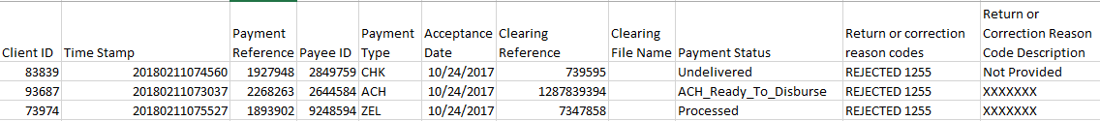

Fr-18 Reports
- The daily Rejected Email/Text and Daily Enrolment reports will be generated by IncedoPay and distributed to the Clients.
- Reports will be available in the IncedoPay client portal, and an email & text may be sent to the Client by IncedoPay including a link for downloading the report.
- Reports will have PII data masked. This will include, if present, the bank account details.
- The format of the report will be CSV

Daily Enrolment Report Sample 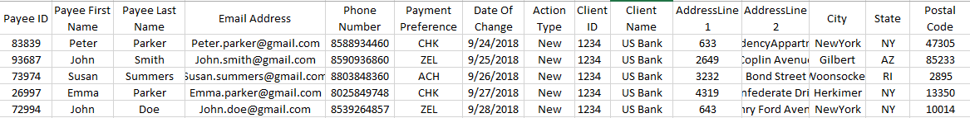
Reject Email/Text Report Sample

Workflows

File Submission Workflow (Workflow 1)
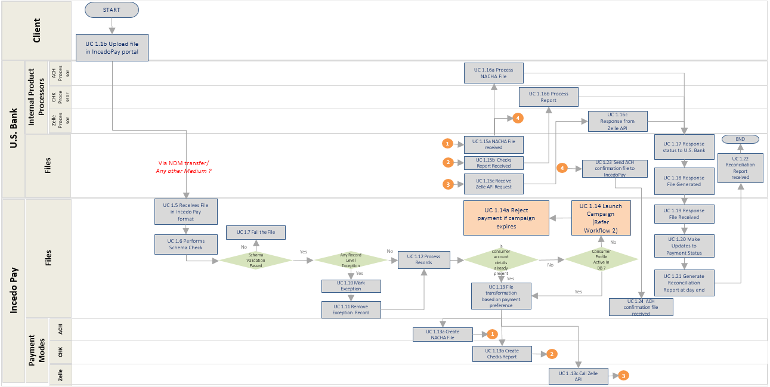

Campaign Standalone Processing (Workflow 2)
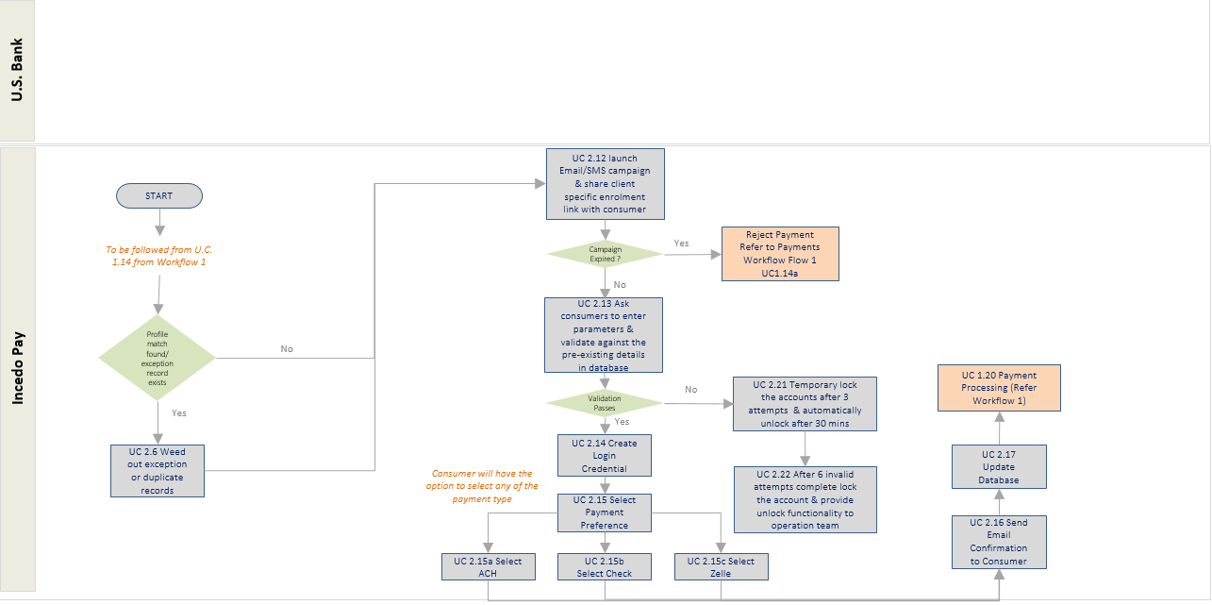

Payment Processing : Payment Type is ”Blank” (Workflow 5)
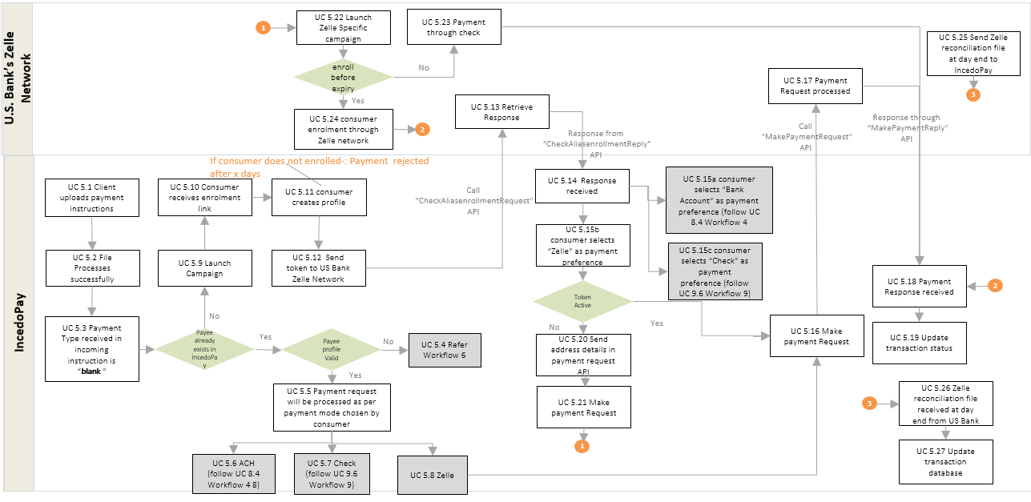

Profile Validation (Workflow 6)
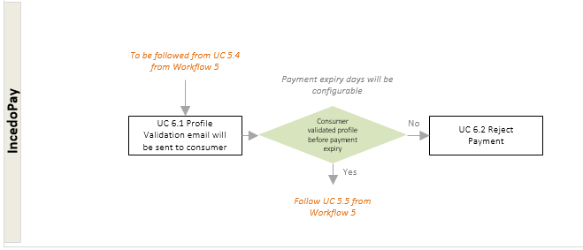

Payment Processing : Payment Type is ”Zelle” (Workflow 7)
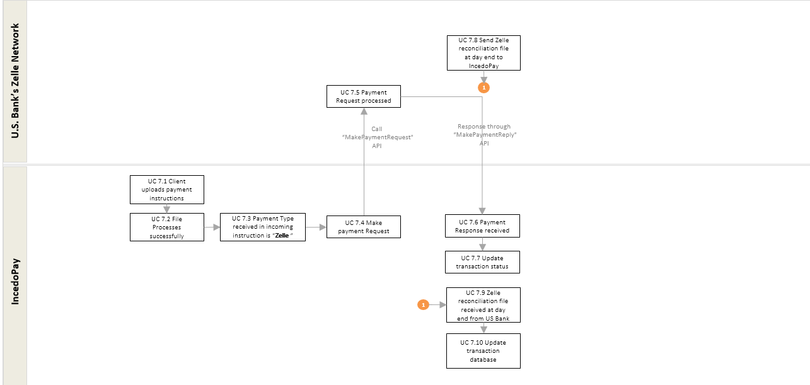

Payment Processing : Payment Type is ”ACH” (Workflow 8)
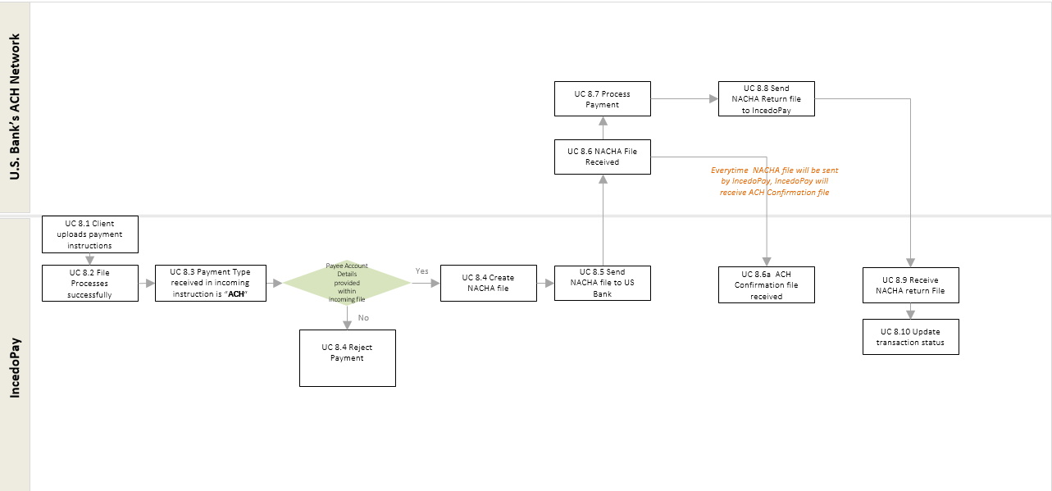

Payment Processing : Payment Type is ”CHK” (Workflow 9)
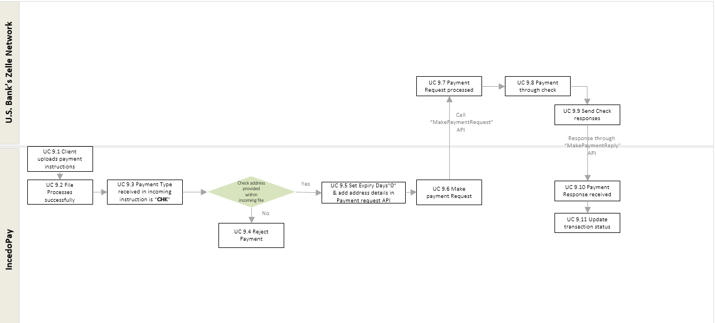

Cancel Payment : Payment Type is ”ACH” (Workflow 10)
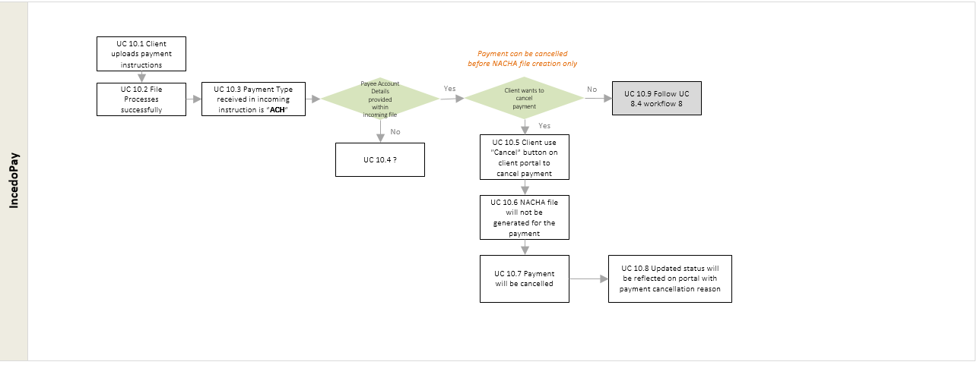

Cancel Payment : Payment Type is ”Zelle” (Workflow 11)
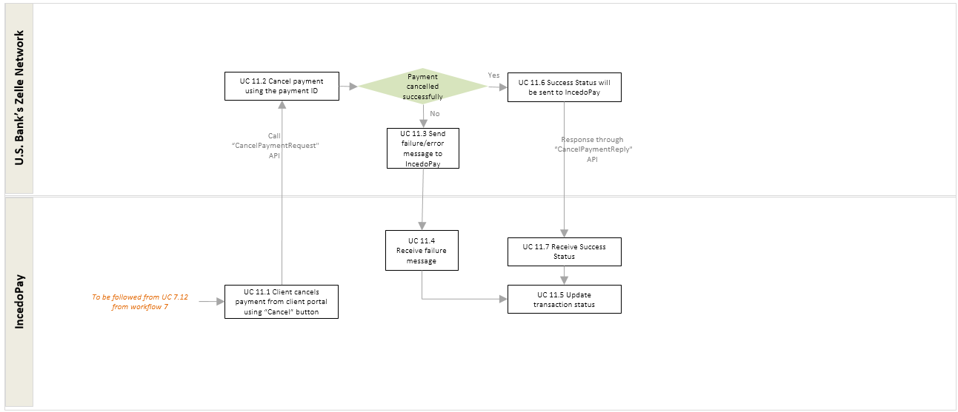

Cancel Payment : Payment Type is ”CHK” (Workflow 12)
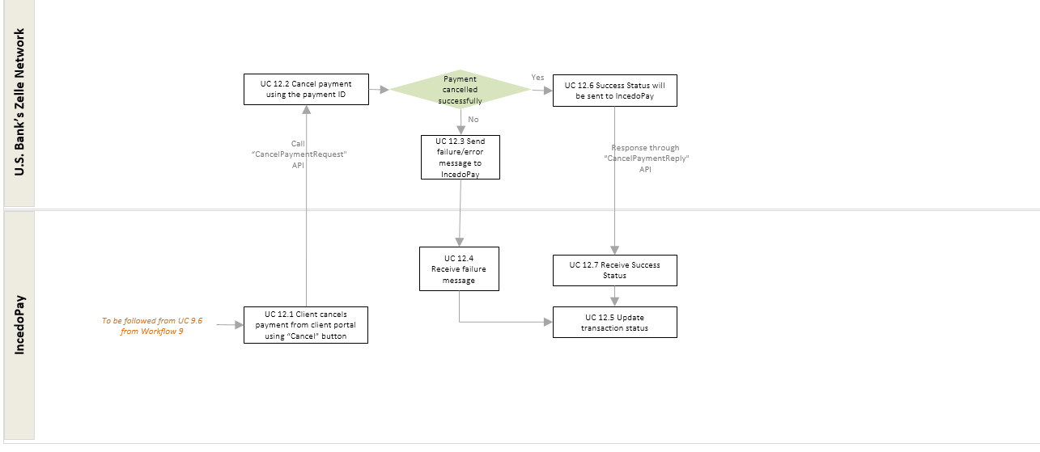

Payment Authorization (Workflow 13)
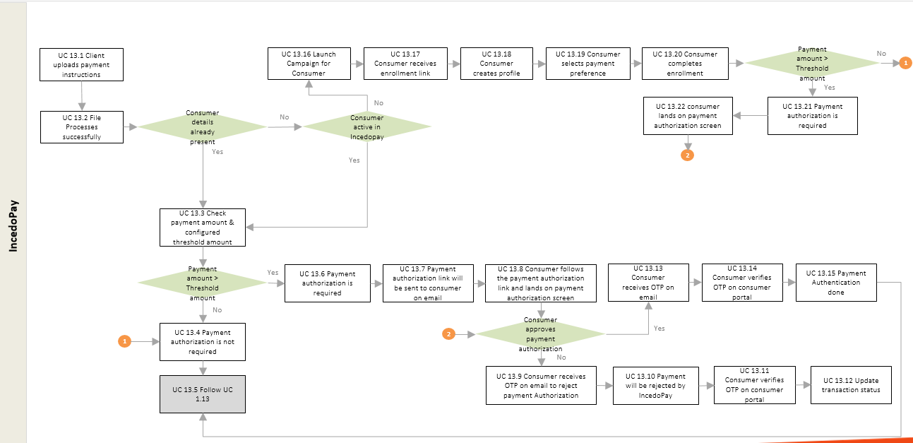

Non Functional Requirements

Volume / Potential Growth
Performance testing must be done to ensure that the application can support the expected volumes.
The expected volumes are as follows:
Number of Clients | Year 1 | Year 2 | Year 3 | Year 4 | Year 5
Small
Medium
Large
TOTAL

Consumer Profiles | Year 1 | Year 2 | Year 3 | Year 4 | Year 5
Small
Medium
Large

Payments to Consumers | Year 1 | Year 2 | Year 3 | Year 4 | Year 5
Small
Medium
Large

Security – Kelly to confirm with Peter Skirvin, Info Sec.
The system must be available for access 24x7 in all regions and time zones.
The standard availability and green zones of the IncedoPay platform will be in place. Green Zone timings will be from 2:30 am EST to 4:30 am EST.
Exchange of files will take place via SFTP.
PII data will be stored encrypted in the IncedoPay database. This PII data typically include Consumer details such as email address phone number, Consumer Account Number ,First Name, Last name. Consumer Account number will be masked.
For high-value payments, the client will be able to enable a multi-factor check to authorise the processing of the transactions.
All transactions and data events will be logged and available in the IncedoPay for audit purposes.

Control (Technology Processing) Requirements

Regulatory & Legal Requirements
All data will be stored in AWS datacenters in the US.

Appendix

Delimited File Format Specification

General
- Each line is character delimited:
  - Possible delimiters are the character ‘|’ (pipe) and ‘,’ (comma).
  - Character selection is based on client preferences
  - Downloadable reports use the delimiter for reports.
  - A file with different characters used as delimiters will not be accepted
    - Field1|Field2|Field3- acceptable
    - Field1,Field2,Field3- acceptable
    - Field1|Field2,Field3- Reject
    - Field1#Field2#Field3- Reject
- Each line represent a single record of data (one payment instruction)
- Data files and downloadable reports extensions will be based on client configuration
- Incoming Data files from clients do NOT use headers or footers. Downloadable reports include a file header.

Data Enclosing
- In order to allow values to include the delimiter character as a value, the text should be enclosed in double quotes. Example:
This is one value, This is a second value, “This, is a third value”
- If double quotes are part of the value, these should be escaped by using double double quotes. Example:
This is one value,This is a second value, “This, is a third ““value”””

Validations

File Level Validation
- Column Validation
  - The content of the file must have the same number of columns specified in the incoming file format defined in this document.
- File Naming Validation
  - If the file does not include a valid name as specified, the file will be rejected.
If any of the validations above fails, the full file will be rejected & error message will be displayed to client on client portal.
Refer to section 6.8 for file level error codes.

Transaction Level Validation
- Field Data Type Validation
  - Records are validated against the data types included in the file layout. These layouts include the following data types
    - Numeric – Value is an integer of no more of x digits where X is defined in the respective file formats.
    - Money – Value represents money with no more than 14 digits with 2 decimal points (14 total)
    - Text – Value represents a maximum of 255 characters
    - Date – Value represents a date AFTER 1/1/1900
    - Email – Value represents a valid email (tbd, reg ex)
    - Phone – Value represents a valid phone number including country code and local code (tbd, regex)
  - Data value trimming
If any of the validations above fails, only the record will be rejected.

General File Naming Convention Recommendations(TBD)

Request or Publish
Item | Description
Client ID* | Client Identification provided by US Bank
Origin Application | Up to 10 chars describing the origin app i.e. INPAY
Destination Application | Up to 10 chars describing the destination app i.e. PH – (Payment Hub)
Content Type | Up to 20 chars describing the content of the file
File Date | Date of the file generation in the following format: YYYYMMDD  Time Zone: EST
Unique File ID | Up to 35 chars for unique record identification it can be a datetime
File Extension | The file extension is by default .dat however .csv can be used if the content allows it.

Example:
ClientUID_APP1_APP2_ContentType_YYYYMMDDUUUUUUUUUUUUUUUUUUUUUUUUUUUUUUUUUUU.dat
Example for a file generated on Sep 5th, 2016 at 8:30:01.332 PM EST:
000000007_PX_PH_ContentType_20160905203001332.dat

Client ID definition
A client id should defined by US Bank. This identification should be maintained whenever files are sent between entities. For example, a client called ACMAY Corp can have the value 1111 and this id will identify the client in any interaction.

Applications
Application | Identification
INPAY | IncedoPay
USBBIL | US Bank Billing
USBACH | Us Bank ACH
USBZEL | US Bank Zelle

Content Types
Content | Identification

Payment Methods
Payment Method | Description
ACH | ACH Method
CHK | Check Method
ZEL | Zelle Method

Consumer Statuses
Consumer Status | Description
Active | Consumer profile activated post enrolment
Auto-Active | Enrolment campaign not required; incoming payment file has all the required details, then consumer profile will be auto-activated
Enrollment pending | Consumer enrolment is pending
Authorization Failed | Consumer profile locked after number of unsuccessful attempts
Enrollment Initiated | Consumer Initiated enrolment (Setup his profile but not chosen payment preference )
Inactive | Consumer profile not validated after configurable number of days
Enrollment Failed | Enrolment email/Text undelivered to consumer
Revoked | Client revoked consumer profile
Deleted | Consumer deleted his profile
Expired | Enrolment campaign expired for consumer
Deactivated | Consumer deactivated by client

Campaign Statuses

Camapign Status | Description
Campaign not required | Enrolment campaign not required for consumer
Campaign Pending | Enrolment link received on email/Text but campaign is not initiated by consumer
Campaign Incomplete | Enrolment Campaign initiated by consumer but not completed the campaign
Campaign Completed | Enrolment campaign completed by consumer

Payment Statuses
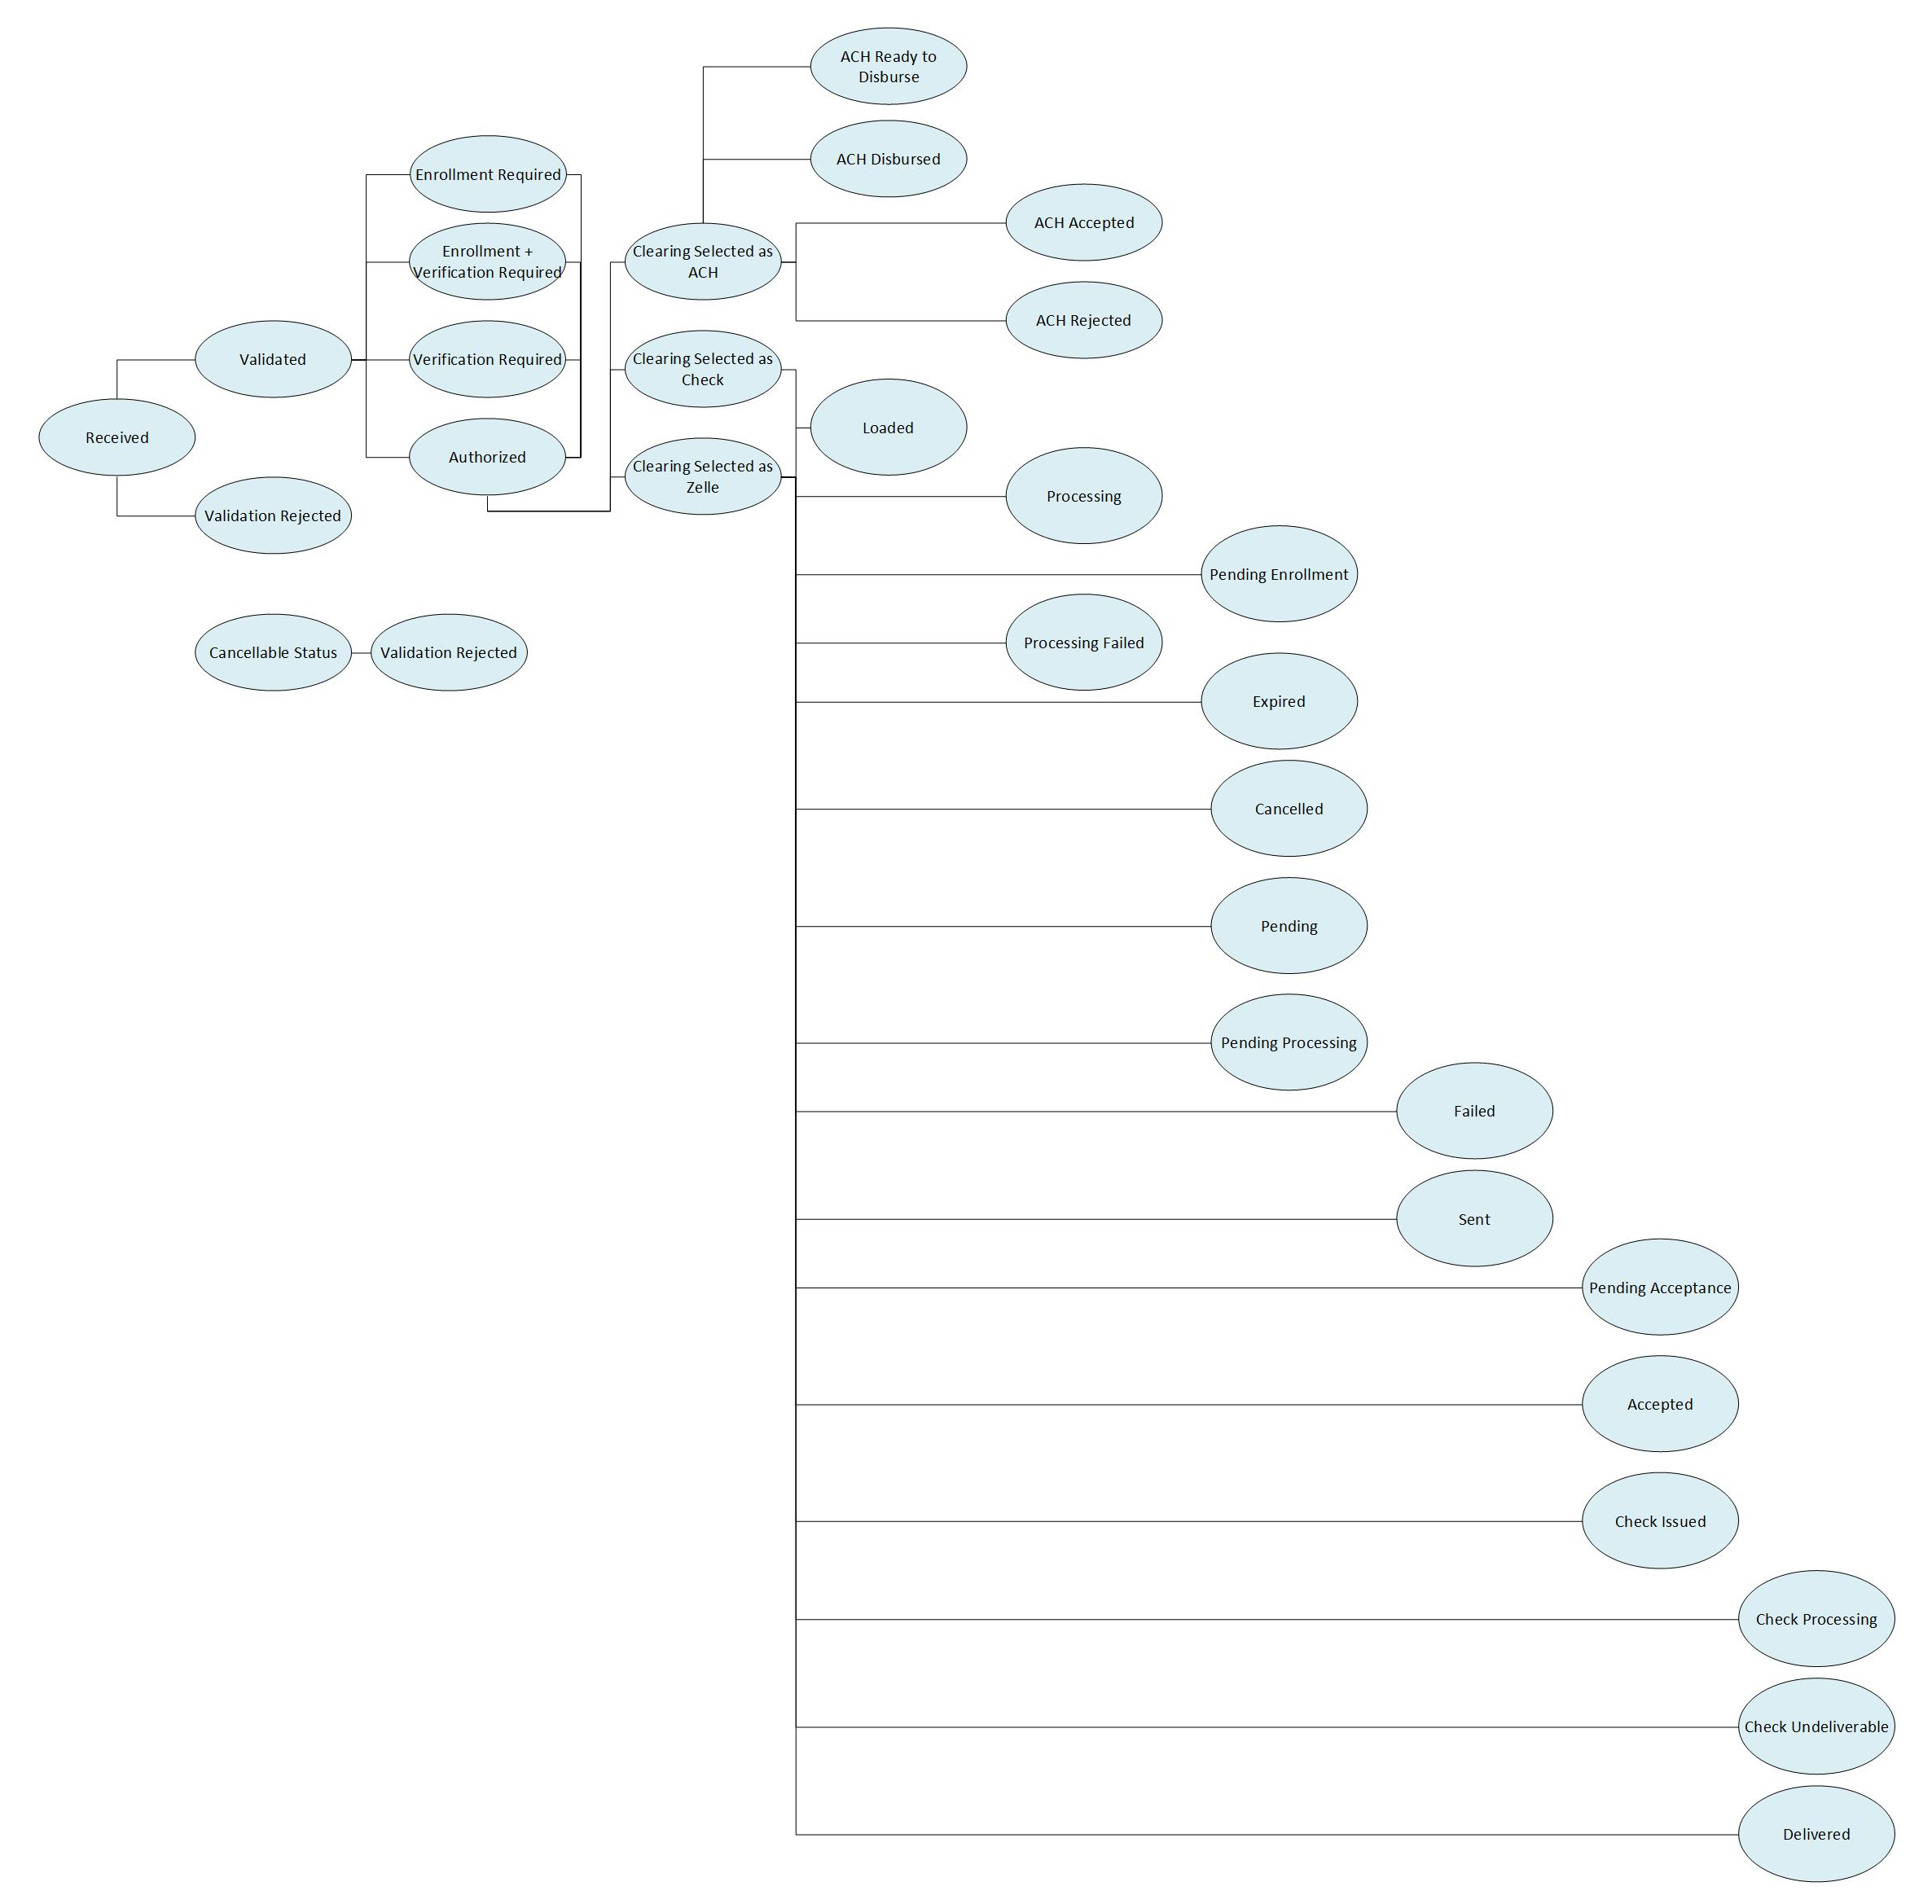

Status | Description | Status | TXSTS | Cancellable
PAYMENT_RECEIVED | Payment Received | PENDING | PDNG | yes
PAYMENT_VALIDATED | Payment Validated | PENDING | PDNG | yes
PAYMENT_VALIDATION_REJECTED | Payment Rejected Due To Validation | REJECTED | RJCT | yes
ENROLMENT_REQUIRED | Enrolment Required | PENDING | PDNG | yes
VERIFICATION_REQUIRED | Verification Required | PENDING | PDNG | yes
ENROL_AND_VERIFY_REQUIRED | Enrolment and Verification Required | PENDING | PDNG | yes
PAYMENT_AUTHORIZED | Payment Authorized | PENDING | PDNG | yes
PAYMENT_REJECTED | Payment Rejected or Cancelled [from IncedoPay] | REJECTED | RJCT | no
ACH_CLEARING | ACH Selected | PENDING | PDNG | yes
ACH_READY_TO_DISBURSE | ACH Ready to Disburse (ACH payment) | PENDING | PDNG | yes
ACH_DISBURSED | ACH Disbursed | PENDING | PDNG | no
ACH_ACCEPTED | ACH Accepted | PROCESSED | ACSC | no
ACH_REJECTED | ACH Rejected | REJECTED | RJCT | no
ZELLE_CLEARING | Zelle Selected | PENDING | PDNG | yes
LOADED | Zelle Payment Initiated | PENDING | PDNG | no
PROCESSING | Zelle Payment Processing | PENDING | PDNG | no
PENDING_ENROLLMENT | Zelle Enrolment Pending | PROCESSED | ACSC | no
PROCESSING_FAILED | Zelle Processing Failed | PROCESSED | ACSC | no
EXPIRED | Zelle campaign Expired | PENDING | ACSC | no
CANCELLED | Zelle Payment Cancelled | REJECTED | RJCT | no
PENDING |  | PENDING | PDNG | no
PENDING_PROCESSING | Payment Processing Pending | PENDING | PDNG | no
FAILED | Payment Failed | REJECTED | RJCT | no
SENT | Payment Sent | PENDING | PDNG | no
PENDING_ACCEPTANCE | Zelle Pending Acceptance | PENDING | PDNG | no
ACCEPTED | Payment Accepted | PROCESSED | ASCS | no
CHECK_CLEARING | Check Selected | PENDING | PDNG | yes
CHECK_PROCESSING | Check Ready to Disburse | PENDING | PDNG | yes
CHECK_ISSUED | Check Disbursed | PENDING | PDNG | no
DELIVERED | Check Accepted | PROCESSED | ACSC | no
CHECK_UNDELIVERED | Check Rejected | REJECTED | RJCT | no

Client configuration TBD
Given the different configurability requirements for Clients, the Client configuration table will need to hold at least the following pieces of information:
Field | Description
Client ID | Unique Identifier of Client
Campaign Required | If campaign enrolment is required for consumer or not
Campaign Type | To choose campaign launch type either through email or SMS or both
Enrolment Type (SSO/Standalone) | Type of enrolment allowed for consumers
Data file format used for reports (CSV) | This is the format in which reports will be sent in.
Number of days for Consumer enrolment | The number of days that IncedoPay will wait for Consumers to enrol before it decides to use the default payment method
Number of days for Payment authorisations | The number of days that IncedoPay will wait for Consumers to provide authorisation of a payment before it decides to use the default payment method.
Number of OTPs allowed for Payment Authorization | Maximum no. of OTPs sent to consumer/allowed to complete payment authorization
OTP Time Validity | Time duration for which OTP will be valid for payment authorization
Process or reject expired payment authorisations | If a payment authorisation expires, this flag indicates whether the payment should be processed or rejected.
Number of days for Consumer profile verifications | The number of days that IncedoPay will wait for Consumers to confirm their dormant profile before it decides to use the default payment method or the one indicated in the dormant profile.
Number of Days for Consumer profile verification Alert | The number of days that IncedoPay will send alert to Consumers to inform them about their dormant profile
Client Threshold for Transaction Approval | The threshold amount above which the client needs to approve the payments in IncedoPay portal prior to processing the payment in the normal flow.
Payment Authorization Threshold Amount | The threshold amount above which the consumer needs to approve the payments in IncedoPay consumer portal prior to processing the payment in the normal flow.
Enrolment Reminder Email/Text | To choose if enrolment reminder is to send to consumer or not.
Payment Priority | To select payment priority
Daily generation time for reconciliation files | Time to generate & send reconciliation file to client on daily basis

Additional Details will be included based on Jodi’s input

Error Codes at the file level
Value | Type | Description
23 | File Level | Zero Records in File
33 | File Level | Invalid File Name
43 | File Level | Invalid Delimiter
53 | File Level | Invalid Amount of Records
73 | File Level | Schema Validation Failed
93 | File Level | Bulk Insertion Failed
200 | File Level | File Processed with Exceptions

List of Reject Reason Codes
In case of a rejection, the following codes can be returned.
System generating the Rejection | Prtry Reason Code | Description | Explanation | Notes
NACHA | R01 | Insufficient funds | Available and/or cash reserve balance is not sufficient to cover the dollar value of the debit Entry. | ALL SEC codes
NACHA | R02 | Account Closed | A previously active account has been closed by action of the customer or the RDFI. | ALL SEC codes
NACHA | R03 | No Account / Unable to Locate Account | Account number structure is valid and it passes the check digit validation, but the account number does not correspond to the individual identified in the Entry, or the account number designated is not an existing account i.e., not an open account. | ALL SEC codes, except ARC, BOC, POP
NACHA | R04 | Invalid Account Number Structure | Account number structure is not valid. | ALL SEC codes
NACHA | R05 | Unauthorized Debit to Consumer Account Using Corporate SEC Code | CCD or CTX debit Entry was transmitted to a Consumer Account of the Receiver and was not authorized by the Receiver. | CCD, CTX SEC codes
NACHA | R06 | Returned per ODFI's Request | ODFI has requested that the RDFI return an Erroneous Entry, or a credit Entry originated without the authorization of the Originator. | ALL SEC codes
NACHA | R07 | Authorization Revoked by Customer | RDFI's customer (the Receiver) revoked the authorization previously provided to the Originator for this debit Entry. | ALL consumer SEC codes, except ARC, BOC, POP, RCK
NACHA | R08 | Payment Stopped | The Receiver has placed a stop payment order on this debit Entry e.g., recurring debit. | ALL SEC codes
NACHA | R09 | Uncollected Funds | A sufficient book or ledger balance exists to satisfy the dollar value of the transaction (i.e., uncollected checks), but the available balance is below the dollar value of the debit entry. | ALL SEC codes
NACHA | R10 | Customer Advises Not Authorized, Improper, or Ineligible | RDFI has been notified by the Receiver that the Entry is unauthorized, improper, ineligible, or part of an incomplete transaction. | ALL SEC codes except CCD, CTX
NACHA | R11 | Check Truncation Entry Return | Used when returning a Check truncation Entry.  [RDFI must use Addenda Record to specify reason for the return e.g., "exceeds dollar amount", "stale date," etc.] | USE IF NO OTHER CODE APPLICABLE
NACHA | R12 | Account Sold to Another DFI | A financial institution received an Entry to an account that was sold to another financial institution. | ALL SEC codes
NACHA | R13 | Invalid ACH Routing Number | Entry contains a Receiving DFI Identification or Gateway Identification that is not a valid ACH routing number. | ALL SEC codes
NACHA | R14 | Representative Payee Deceased or Unable to Continue in That Capacity | Representative payee is either deceased or unable to continue in that capacity. The beneficiary is not deceased. | ALL SEC codes
NACHA | R15 | Beneficiary or Account Holder (Other Than a Representative Payee) Deceased | (1) The beneficiary is deceased, or (2) The account holder is deceased. | ALL SEC codes
NACHA | R16 | Account Frozen / Entry Returned Per OFAC Instruction | (1) Access to the account is restricted due to specific action taken by the RDFI or by legal action; or (2) OFAC has instructed the RDFI or Gateway to return the Entry. | ALL SEC codes
NACHA | R17 | File Record Edit Criteria | Field(s) cannot be processed by RDFI.  [If the Entry cannot be processed by the RDFI, the field(s) causing the error must be identified in the Addenda Information field of the Return.] | ALL SEC codes
NACHA | R18 | Improper Effective Entry Date | (1) The effective Entry date for a credit Entry is more than two Banking Days after the Banking Day of processing as established by the Originating ACH Operator; or (2) The Effective Entry Date for a debit Entry is more than one Banking Day after the processing date. | ALL SEC codes
NACHA | R19 | Amount Field Error | (1) Amount field is non-numeric.  (2) Amount field is not zero in a Prenotification, DNE, ENR, Notification of Change, refused Notification of Change, or zero dollar CCD, CTX, or IAT Entry.  (3) Amount field is zero in Entry other than a Prenotification, DNE, ENR, Notification of Change, Return, Dishonored Return, contested Dishonored Return, or zero dollar CCD, CTX, or IAT Entry.  (4) Amount field is greater than $25,000 for ARC, BOC, POP Entries. | ALL SEC codes
NACHA | R20 | Non-Transaction Account | ACH Entry to a non-Transaction Account i.e., an account against which transactions are prohibited or limited. | ALL SEC codes
NACHA | R21 | Invalid Company Identification | The Identification Number used in the Company Identification Field is not valid. | CIE SEC code
NACHA | R22 | Invalid Individual ID Number | The Receiver has indicated to the RDFI that the number with which the Originator was identified is not correct. | ALL SEC codes
NACHA | R23 | Credit Entry Refused by Receiver | Any credit Entry that is refused by the Receiver may be returned by the RDFI. | ALL SEC codes
NACHA | R24 | Duplicate Entry | The RDFI has received what appears to be a duplicate Entry i.e., the trace number, date, dollar amount and/or other data matches another transaction. | ALL SEC codes
NACHA | R25 | Addenda Error | Addenda record value indicator is incorrect.  Addenda Type Code is invalid, out of sequence, or missing.  Number of Addenda Records exceeds allowable maximum.  Addenda Sequence Number is invalid.
NACHA | R26 | Mandatory Field Error | Erroneous data or missing data in a mandatory field. | ALL SEC codes
NACHA | R27 | Trace Number Error | (1) Original Entry Trace Number is not present in the Addenda Record on a Return or Notification of Change Entry; or  (2) Trace Number of an Addenda Record is not the same as the Trace Number of the preceding Entry Detail Record. | ALL SEC codes
NACHA | R28 | Routing Number Check Digit Error | The Check digit for a routing number is not valid. | ALL SEC codes
NACHA | R29 | Corporate Customer Advises Not Authorized | The RDFI has been notified by the Receiver (non-consumer) that a specific Entry has not been authorized by the Receiver. | CCD & CTX SEC codes
NACHA | R30 | RDFI Not Participant in Check Truncation Program | RDFI does not participate in a Check truncation program. | ALL SEC codes
NACHA | R31 | Permissible Return Entry (CCD and CTX) only | RDFI may return a CCD or CTX Entry that the ODFI agrees to accept. | CCD & CTX SEC codes
NACHA | R32 | RDFI Non-Settlement | RDFI is not able to settle the Entry. | ALL SEC codes
NACHA | R33 | Return of XCK Entry | This Return Reason Code may only be used to return XCK Entries and is at the RDFI's sole discretion. | XCK SEC code
NACHA | R34 | Limited Participation DFI | RDFI's participation has been limited by a federal or state advisor e.g., bank closure. | ALL SEC codes
NACHA | R35 | Return of Improper Debit Entry | Debit Entries (with the exception of Reversing Entries) are not permitted for CIE Entries or to loan accounts. | ALL SEC codes, except CIE
NACHA | R36 | Return of Improper Credit Entry | ACH Entries (with the exception of Reversing Entries) are not permitted for use with ARC, BOC, POP, RCK, TEL, WEB, and XCK. | ALL SEC codes, except ARC, BOC, POP, RCK, TEL, WEB, & XCK
NACHA | R37 | Source Document Presented for Payment | The source document to which an ARC, BOC, or POP Entry relates has been presented for payment. | ARC, BOC, POP SEC codes
NACHA | R38 | Stop Payment on Source Document | RDFI determines a stop payment order has been placed on the source document to which the ARC or BOC Entry relates. | ARC, BOC SEC codes
NACHA | R39 | Improper Source Document / Source Document Presented for Payment | RDFI determines that:  (1) the source document used for an ARC, BOC, or POP Entry to its Receiver's account is improper, or  (2) an ARC, BOC, or POP Entry and the source document to which the Entry relates have been presented for payment and posted to the Receiver's account. | ARC, BOC SEC codes
NACHA | R40 | Return ENR Entry by Federal Government Agency | This Return Reason Code may only be used to return ENR Entries and is at the Federal Government Agency's sole discretion. | ENR SEC code
NACHA | R41 | Invalid Transaction Code | Either the Transaction Code included in Field 3 of the Addenda Record does not conform to the ACH Record Format Specifications contained in Appendix Three (ACH Record Format Specifications) or it is not appropriate with respect to an Automated Enrollment Entry. | ENR SEC code
NACHA | R42 | Routing Number / Check Digit Error | The Routing Number and the Check Digit included in Field 3 of the Addenda Record is either not a valid number or it does not conform to the Modulus 10 formula. | ENR SEC code
NACHA | R43 | Invalid DFI Account Number | The Receiver's account number included in Field 3 of the Addenda must include at least one alphameric character. | ENR SEC code
NACHA | R44 | Invalid Individual ID Number / Identification Number | The Individual ID Number / Identification Number provided in Field 3 of the Addenda Record does not match a corresponding ID number in the Federal Government Agency's records. | ENR SEC code
NACHA | R45 | Invalid Individual Name / Company Name | The name of the consumer or company provided in Field 3 of the Addenda Record either does not match a corresponding name in the Federal Government Agency's records or fails to include at least one alphameric character. | ENR SEC code
NACHA | R46 | Invalid Representative Payee Indicator | The Representative Payee Indicator Code included in Field 3 of the Addenda Record has been omitted or it is not consistent with the Federal Government Agency's records. | ENR SEC code
NACHA | R47 | Duplicate Enrollment | The Entry is duplicate of an Automated Enrollment Entry previously initiated by a DFI. | ENR SEC code
NACHA | R50 | State Law Affecting RCK Acceptance | (1) The RDFI is located in a state that has not adopted Revised Article 4 of the Uniform Commercial Code (1990 Official Text) and has not revised its customer agreements to allow for Electronic presentment; or  (2) The RDFI is located within a state that requires all canceled Checks to a specific type of account to be returned to the Receiver within the periodic statement. | RCK SEC code
NACHA | R51 | Item related to RCK Entry is Ineligible for RCK Entry is Improper | A RCK Entry considered to be ineligible or improper. | RCK SEC code
NACHA | R52 | Stop Payment on Item Related to RCK Entry | A stop payment order has been placed on the item to which the RCK Entry relates. | RCK SEC code
NACHA | R53 | Item and RCK Entry Presented for Payment | In addition to an RCK Entry, the item to which the RCK Entry relates has also been presented for payment. | RCK SEC code
NACHA | R61 | Misrouted Return | The financial institution preparing the Return Entry (the RDFI of the original Entry) has placed the incorrect Routing Number in the Receiving DFI Identification field. | ALL SEC codes, except IAT
NACHA | R62 | Return of Erroneous or Reversing Debit | The Originator's / ODFI's use of the reversal process has resulted in, or failed to correct, an unintended credit to the Receiver. | ALL SEC codes, except IAT
NACHA | R67 | Duplicate Return | The ODFI has received more than one Return for the same Entry. | ALL SEC codes, except IAT
NACHA | R68 | Untimely Return | The Return Entry has not been sent within the time frame established by these Rules. | ALL SEC codes, except IAT
NACHA | R69 | Field Error(s) | One or more of the field requirements are incorrect. | ALL SEC codes, except IAT
NACHA | R70 | Permissible Return Entry Not Accepted / Return Not Requested by ODFI | The ODFI has received a Return Entry identified by the RDFI as being returned with the permission of, or at the request of, the ODFI, but the ODFI has not agreed to accept the Entry or has not requested the return of the Entry. | ALL SEC codes, except IAT
NACHA | R71 | Misrouted Dishonored Return | The financial institution preparing the dishonored Return Entry (the ODFI of the original Entry) has placed the incorrect Routing Number in the Receiving DFI Identification field. | ALL SEC codes, except IAT
NACHA | R72 | Untimely Dishonored Return | The dishonored Return Entry has not been sent within the designated time frame. | ALL SEC codes, except IAT
NACHA | R73 | Timely Original Return | The RDFI is certifying that the original Return Entry was sent within the timeframe designated in these Rules. | ALL SEC codes, except IAT
NACHA | R74 | Corrected Return | The RDFI is correcting a previous Return Entry that was dishonored using Return Reason Code R69 (Field Error(s)) because it contained incomplete or incorrect information. | ALL SEC codes, except IAT
NACHA | R75 | Return Not a Duplicate | The Return Entry was not a duplicate of an Entry previously returned by the RDFI. | ALL SEC codes, except IAT
NACHA | R76 | No Errors Found | The original Return Entry did not contain the errors indicated by the ODFI in the dishonored Return Entry. | ALL SEC codes, except IAT
NACHA | R76 | Non-Acceptance of R62 Dishonored Return | The RDFI returned both the Erroneous Entry and the related Reversing Entry, or the funds relating to the R62 dishonored Return are not recoverable from the Receiver. | ALL SEC codes, except IAT
NACHA | R80 | IAT Entry Coding Error | The IAT Entry is being returned due to one or more of the following conditions:  ▪ Invalid DFI / Bank Branch Country Code  ▪ Invalid DFI / Bank Identification Number Qualifier  ▪ Invalid Foreign Exchange Indicator  ▪ Invalid ISO Originating Currency Code  ▪ Invalid ISO Destination Currency Code  ▪ Invalid ISO Destination Country Code  ▪ Invalid Transaction Type Code | IAT SEC code
NACHA | R81 | Non-Participant in IAT Program | The IAT Entry is being returned because the Gateway does not have an agreement with either the ODFI or the Gateway's customer to transmit Outbound IAT Entries. | IAT SEC code
NACHA | R82 | Invalid Foreign Receiving DFI Identification | The reference used to identify the Foreign Receiving DFI of an Outbound IAT Entry is invalid. | IAT SEC code
NACHA | R83 | Foreign Receiving DFI Unable to Settle | The IAT Entry is being returned due to settlement problems in the foreign payment system. | IAT SEC code
NACHA | R84 | Entry Not Processed by Gateway | For Outbound IAT Entries, the Entry has not been processed and is being returned at the Gateway's discretion because the processing of such Entry may expose the Gateway to excessive risk. | IAT SEC code
NACHA | R85 | Incorrectly Coded Outbound International Payment | The RDFI/Gateway has identified the Entry as an Outbound internal payment and is returning the Entry because it bears an SEC Code that lacks information required by the Gateway for OFAC Compliance.  [For Gateway use only.] | ALL SEC codes, except IAT
NACHA | C01 | Incorrect DFI Account Number | Correct DFI Account Numbers appears in First 17 characters of the correct data field | ALL SEC codes, except IAT
NACHA | C02 | Incorrect Routing Number | Correct Routing Number (including check digit) appears in first 9 characters of the corrected data field. | ALL SEC codes, except IAT
NACHA | C03 | Incorrect Routing number and Incorrect DFI Account Number | Correct Routing Number appears in first nine position of the corrected data field  Correct DFI account appears in the in the 13th through 29th position of the same field with space in between 10 and 12. | ALL SEC codes, except IAT
NACHA | C04 | Incorrect individual name / receiving company name | Correct Individual Name / Receiving Company Nameappears in first 22 positions of the corrected data field. | ALL SEC codes, except IAT
NACHA | C05 | Incorrect Transction Code | Correct Transaction Code appears in the first two position of the correct data field | ALL SEC codes, except IAT
NACHA | C06 | Incorrect DFI Account Number and Incorrect Transaction Code | Correct DFI Account Number appears in first 17 positions of the corrected data field, correct transaction code appears in the 21st and 22nd position of the same field with space in 18th and 20th positions. | ALL SEC codes, except IAT
NACHA | C07 | Incorrect Routing Number, Incorrect DFI Account Number and Incorrect Transaction code | Correct Routing Number appears in the first 9 positions, correct DFI account appears in the 10through 26th positions, and correct transaction code appears in the 27th and 28th position of the corrected data field | ALL SEC codes, except IAT
NACHA | C08 | Incorrect Receiving DFI Identification |  | IAT SEC Code
NACHA | C09 | Incorrect individual identification number | Correct Number appears in first 22 positions of the corrected data field | ALL SEC codes, except IAT
NACHA | C13 | Addeda Format Error | Information in the entry detail record was correct and the entry was posted by the RDFI . however information found in the addenda record was unclear or was formed incorrectly. | ALL SEC codes, except IAT
Payment | DUPL | Payment is a duplicate of another payment | Generated when the duplicate detection logic in the IncedoPay determines that a payment is a duplicate.
Payment | DS02 | An authorized user has cancelled the order | Payment rejected in the threshold-based customer level approval.
Payment | ED05 | Settlement of the transaction has failed | Payment rejected for a missing required field.

ACH File Confirmation Error Codes
The following table details the error codes that would IncedoPay get in ACH confirmation file in field no.29.
Message Code | Description
Msg 000 | No errors
Msg 001 | File sequence error / previous record type Y
Msg 002 | File contains only 1 & 9 Records
Msg 003 | No File Header before First Batch Header; Dummy added
Msg 004 | Debit amounts not equal to calculated amount
Msg 005 | Debit Entry Dollar field not numeric
Msg 006 | Credit Amounts not equal to calculated amount
Msg 007 | Credit Entry Dollar field not numeric
Msg 008 | File trailer record missing; dummy added
Msg 009 | File trailer found not of sequence
Msg 010 | File trailer misplaced in file
Msg 011 | Eff Entry Date is a NON PEP+ business date
Msg 012 | Eff Entry Date is over 60 days from today
Msg 013 | Eff Entry Date is invalid
Msg 014 | Company Entry Description is blank (Susp / Warning) NOT FATAL
Msg 015 | Company ID is blank
Msg 016 | Company Name is blank
Msg 017 | Invalid ODFI ID field
Msg 018 | First Batch Header missing; dummy added
Msg 019 | Invalid total Debit Entry Dollar Field
Msg 020 | Invalid total Credit Entry Dollar Field
Msg 021 | Unable to read PPSCH Calendar for Eff Date
Msg 022 | Requested CA Not Found (Susp / Warning) NOT FATAL
Msg 023 | Invalid Transaction Code
Msg 024 | Receiving RT is not numeric
Msg 025 | Invalid Debit / Credit Amount Field
Msg 026 | Prenote TC with Dollar amount >0 (live)
Msg 027 | Invalid Addenda Record Indicator
Msg 028 | Transaction Addenda records exceed 9,999
Msg 029 | Addenda Record was not expected
Msg 030 | Addenda Record is missing

Unified Status Response Codes List Zelle API
This table defines all status response codes which can be returned by Zelle APIs operations defined in the document.
Status | Description
0/Success |  | Operation Successful.
1001/Error |  | General error.  Unknown/uncaptured cause.
1013/Error |  | Field is required – Empty payment parameter name/value is disallowed
3003/Error |  | Payer Not Found  The supplied Payer ID is unknown to B2C-CXC system.
5002/Error |  | Payment not found  The referenced payment could not be found.
5003/Error |  | Payment cancellation disallowed due to either completion or payment status not cancellable  (A generic error message: any validation failures resulted from conditions not expressed by explicit rules)
5004/Error |  | Payment alias mismatch  The alias was supplied on a cancel request, and that alias didn't match the information in the original payment.
5005/Error |  | Payment amount mismatch  The payment amount was supplied on a cancel request, and that amount didn't match the information in the original payment.
5006/Error |  | Zelle payment ID empty  The targeted payment, identified by the Payment Instruction ID, has no Zelle Payment Id associated with it, and thus cannot be cancelled.
5007/Error |  | Payment cancellation failed at ESD  Cancel failed due to upstream service call failures.
5008/Error |  | Invalid payment status change  Cancel failed due to upstream service call returning server error status: 37723/INVALID PAYMENT STATUS CHANGE
5009/Error |  | Payment cannot be cancelled because it has already been sent for processing  (Validation rule: PAYMENT_INSTRUCTION.CXC_PAYMENT_STATUS==SENT && PAYMENT_INSTRUCTION.ACH_CREATE_DATE!=NULL)
5010/Error |  | Payment cannot be cancelled as it is currently processing, please try again later  (Validation rule: PAYMENT_INSTRUCTION.STATUS == PROCESSING)
5011/Error |  | [Standard] payment cannot be cancelled due to current [FAILED] status  (Validation rule: PAYMENT_INSTRUCTION.CXC_PAYMENT_STATUS == DELIVERED/EXPIRED/FAILED)
6001/Error |  | Payment amount exceeds transaction limit  Payment would have violated the various limits in place.
6002/Error |  | Payment account not found.  If payment account was specified, that account was not found in Payer's set of payment accounts.  If payment account was not specified, the Payer does not have a default payment account configured.
6003/Error |  | Invalid email alias.  Email alias did not pass validation.
6004/Error |  | Invalid phone number alias.  Mobile phone alias did not pass validation.
6005/Error |  | Invalid US State  Recipient address specified an invalid 2-letter US state code.
6006/Error |  | Make Payment processing failed  Payment processing failed due to upstream service failures.

Common Entry Class Codes (NACHA)
Code | Description
CCD |  | Cash Concentration
CTX |  | Corporate Trade Exchange
PPD |  | Prearranged Payment and Deposit Entry

Common Transaction Codes (NACHA)
Code | Description
32 |  | Savings Credit
33 |  | Savings Credit Prenote
37 |  | Savings Debit
38 |  | Savings Debit Prenote
22 |  | Checking Credit
23 |  | Checking Credit Prenote
27 |  | Checking Debit
28 |  | Checking Debit Prenote

Email Notifications List
Sr. No | Template ID | Template Summary | Trigger Point
1 | 1 | Enrolment Invitation | Payment Type is “Blank” in incoming payment file and payee doesn’t exist in IncedoPay
2 | 2 | Bank Account Enrolment Confirmation | After enrolment is complete in case consumer selects Payment Preference as ‘Bank Account’
3 | 3 | Check Enrolment Confirmation | After enrolment is complete in case consumer selects Payment Preference as ‘Check’
4 | 4 | Zelle Enrolment Confirmation | After enrolment is complete in case consumer selects Payment Preference as ‘Zelle’
5 | 5 | Enrolment Reminder | To send reminder to consumer if consumer is not enrolled within configurable days
6 | 6 | Payment Authentication Invitation | If Payment Amount > threshold amount configured by client, then payment authorization will be required
7 | 7 | Payment Authentication OTP | This mail notification will send OTP to consumer for payment Authorization.
8 | 8 | Payment Authentication Confirmation | Consumer receives this notification in case Payment Authentication done successfully.
9 | 9 | Profile Update | Any update made by the consumer in his profile
10 | 10 | Password Update | Consumer updates the password
11 | 11 | Password Reset | Consumer resets the password
12 | 12 | Payment Preference Details Update – Bank | Consumer update details of his Bank Account
13 | 13 | Payment Preference Details Update - Check | Consumer update details for check
14 | 14 | Payment Preference Details Update - Zelle | Consumer update details for Zelle
15 | 15 | Payment Preference Update – Bank Account | Consumer updates his payment preference as “Bank Account”
16 | 16 | Payment Preference Update – Check | Consumer updates his payment preference as “Check”
17 | 17 | Payment Preference Update – Zelle | Consumer updates his payment preference as “Zelle”
18 | 18 | Lock Payee | Consumer account locked
19 | 19 | Unlock Payee | Consumer account unlocked
20 | 20 | Profile Delete | Profile deleted by consumer
21 | 21 | Profile Deactivated | Profile deactivated by client
22 | 22 | Profile Validate | Consumer profile is inactive after configurable number of days, notification will be sent to consumer to validate profile
23 | 23 | Profile Validation Confirmation | Profile validation is completed by consumer
24 | 24 | Revoke Payee | Consumer is revoked by client
25 | 25 | Payment Status | Any update in payment status
26 | 26 | Client Onboarding | New Client Onboards
27 | 27 | Client onboarding confirmation | Client onboarding completed
28 | 28 | Password Reset | Client user resets password
29 | 29 | Password Update | Client user updated his password
30 | 30 | File Upload Status | Status Update on File Upload
31 | 31 | File Exception | Report file level exception
32 | 32 | Record Exception | Report record level exception
33 | 34 | Daily Enrolment Report | Enrolment report on daily basis
34 | 35 | Daily Reject Email/Text Report | Email/Text Rejection report on daily basis
35 | 36 | Default Payment Report | Payments report processed basis on client's default payment method
36 | 37 | Payment Expiry Report | Report to inform enrolment link expiry
37 | 38 | Reconciliation Report | Payment Report on daily basis
38 | 39 | Exception Report | Report for exceptions

NACHA Return File Specifications
Below attached is the document to refer for NACHA return file specifications.

Client Onboarding Form Fields

Value | Purpose | Source | Data Provided for Input to | Data Input & Stored
Company name | Account setup | On-boarding form | Incedo | refund portal
Email address | Account setup | On-boarding form | Incedo | refund portal
login type | Account setup | On-boarding form | Incedo | refund portal
phone | Account setup | On-boarding form | Incedo | refund portal
Tax ID | Account setup | On-boarding form | Incedo | refund portal
City | Initial user setup | On-boarding form | Bank | refund portal
Country | Initial user setup | On-boarding form | Bank | refund portal
Zip | Initial user setup | On-boarding form | Bank | refund portal
State | Initial user setup | On-boarding form | Bank | refund portal
Name Prefix | Initial user setup | On-boarding form | Bank | refund portal
First name | Initial user setup | On-boarding form | Bank | refund portal
Last name | Initial user setup | On-boarding form | Bank | refund portal
User name | Initial user setup | On-boarding form | Bank | refund portal
Password | Initial user setup | Generic | Bank | refund portal
Payment type | Initial user setup | On-boarding form | Bank | refund portal
Email | Initial user setup | On-boarding form | Bank | refund portal
Phone | Initial user setup | On-boarding form | Bank | refund portal
Security Question and answer | Initial user setup | Generic | Bank | refund portal
ACH company ID | ACH setup | On-boarding form | Incedo | Refund Backend
Immediate Destination | ACH setup | Same for all | Incedo | Refund Backend
Immediate Orgin | ACH setup | Same for all | Incedo | Refund Backend
Immediate Orgin Name | ACH setup | Same for all | Incedo | Refund Backend
Company Entry Description | ACH setup | On-boarding form | Incedo | Refund Backend
Originating DFI Identification | ACH setup | Same for all | Incedo | Refund Backend
Routing Number for ACH payments | ACH setup | On-boarding form | Incedo | Refund Backend
Account number for ACH payments | ACH setup | On-boarding form | Incedo | Refund Backend
Zelle payer ID | Zelle setup | On-boarding form | Incedo | Refund Backend
Billing account number | Billing setup | On-boarding form | Incedo | Refund Backend
Billing account company number | Billing setup | On-boarding form | Incedo | Refund Backend
Blank | Check Setup | On-boarding form | Incedo | Refund Backend

International ACH Transactions

